IALA Guideline

Gnnnn
Guideline on Digitalization of Waterways

Edition x.x
Date (of approval by Council)

urn:mrn:iala:pub:gnnnn
Revisions to this document are to be noted in the table prior to the issue of a revised document.
Date | Details | Approval

1. Introduction and overview 6
1.1. Overview 6
1.2. Scope 6
2. Digitalisation Maturity 7
2.1. Owerview 7
2.2. Digital Maturity Frameworks and Standards 7
2.3. Capability Maturity Model for Waterways 7
2.4. Digitalisation Challenges 11
2.4.1. Increased interdependency 11
2.4.2. Match-principle 11
2.4.3. Mixed Traffic conditions 12
3. Digital model, shadow and Twin of waterway 16
3.1. Overview 16
3.2. Types of Digital Models 17
3.3. Construction of Digital Twins 17
3.3.1. Data Management Plan 18
3.3.2. Information Presentation System 18
3.3.3. Sensor network 19
3.3.4. Connectivity 19
3.4. Maturity of Waterway digital Models 19
4. Digital Services for navigation in waterways 21
4.1. Overview 21
4.2. Digital services for Waterways as defined by IMO 22
4.3. Digital services for Waterways as defined by PIANC 22
4.4. S-100 data products and technical Services 24
4.5. Maturity of Digital Maritime Services 27
5. Architectures for Digitalisation of waterways 29
5.1. Overview 29
5.2. Datalink Communications Architecture 29
5.3. The Infrastructure Site Architecture 30
5.4. The System Interconnection Architecture 31
5.5. The Overarching Waterway Domain Architecture 32
5.5.1. Shipboard Navigation System Architecture 33
5.5.2. The Common Shore-based System Architecture 34
5.6. The Maritime Architecture Framework 35
5.6.1. RAMI cube framework architecture 36
5.6.2. Adaptation to Maritime Architecture Framework 37
6. Putting existing generic AtoN and VTS applications into the picture 39
6.1. Overview 39
6.2. Digital shadows of remotely monitored floating visual Aids 39
6.3. Digital AtoN as outposts of the waterway authority towards shipping 41
6.3.1. Application Scenarios 41
6.3.2. Service provision considerations 41
6.3.3. Design requirements 42
6.3.4. Location selection 43
6.3.5. Engineering considerations for Digital AtoNs 44
6.4. Vessel Traffic management by using digital twins 45
7. OUTLOOK ON FUTURE, BUT IMMINENT PARADIGMATIC DEVELOPMENTS 46
7.1. Overview 46
7.2. Concept of the Metaverse and its derivatives 46
7.3. Concept of the Physical Internet 46
8. DEFINITIONS 47
9. abbreviations 50
10. references 51
11. Further reading 52
12. Index 53

List of Tables
Table 1 Maturity levels of digital twins. 19
Table 2 Maritime Services in the Context of e-Navigation. 22
Table 3 Operational River Information Services (RIS) defined by PIANC. 23
Table 4 List of known IHO S-100 based product specifications 26
Table 5 Airport runway service categories [18]. 27
Table 6 Digital maturity levels of navigational services 27
Table 7 Example calculations for time available for data communications at Waterway Infrastructure Site Architecture 31
Table 8 Compilation of meaning of the Layers of Interest. 37
Table 9 AIS message transmission frequency 42

List of Figures
Figure 1 Digitalisation Levels defined for Inland Waterway domain. 8
Figure 2 Digitalisation levels applied to generic entities of the Waterway domain. 10
Figure 3 Overview of generic mixed target fleet and different generic infrastructures and centres provided by shipping companies and shore authorities [7]. 12
Figure 4 Generic operational relationships and resulting generic communications relationships [7]. 14
Figure 5 Digital Model - Digital Shadow – Digital Twin [14]. 16
Figure 6 Digital Twin in Waterway management. 17
Figure 7 The relationship between specifications of Maritime Services, Technical Services and S-100 data models/product specifications and connectivity. 25
Figure 8 Voice and datalink communications implied by overarching e-navigation architecture 29
Figure 9 Example of the use of Waterway Infrastructure Site Architecture. 30
Figure 10 Maritime System Interconnection Architecture. 31
Figure 11 Overarching Waterway domain Architecture 33
Figure 12 Generic shipboard navigation system architecture in the context of e-navigation 34
Figure 13 Structural overview on Common Shore-based System Architecture (CSSA). 35
Figure 14 Representation of Reference Architecture Industry 4.0 as a RAMI cube. 36
Figure 15 Maritime Architecture Framework 37
Figure 16 Example of AtoN monitoring information. 40
Figure 17 Example of an on-demand AtoN used for increasing the intensity of AtoN lights based on traffic information from AIS (yellow trigger areas) and prevailing visibility (blue visibility meter). 40

Introduction and overview

Overview

This guideline defines and explains what is meant by the digitalisation of a waterway.
It also illustrates how digitalisation can benefit the safety and efficiency of navigation, the protection of the environment, the efficient maintenance of waterways and/or of the individual waterway infrastructure components.
Digitalisation of a waterway means increasing the digitalisation maturity of a waterway as a comprehensive infrastructure entity. This includes three themes as follows:
- Creating a digital model of the waterways, which may be further developed to a digital shadow and ultimately to a digital twin;
- Providing digital services to vessels regarding their navigation within the waterways and/or regarding vessel traffic;
- Governing the interactions of the above by a set of mutually supportive architectures for digitalisation.
Waterway with digital capabilities can support more optimized and predictive maintenance of individual waterway infrastructure components such as AtoNs and initiate any proactive corrective actions necessary to individual vessels or to the vessel traffic in general taking into account its prevailing conditions in real-time.
Section 2 of this guideline introduces the concept of digital maturity, methods to determine it, and how it may be applied to waterway, its associated infrastructure, data, and services. In addition, this section generically considers certain conditions to be taken into account for the digitalisation of waterways, such as the requirement to support various mixed traffic scenarios, which create challenges for the digitalisation of waterways.
Section 3 explains the concepts of digital model, digital shadow and digital twin and how these can be applied.
Section 4 discusses digital services, which can be provided to vessels/waterborne vehicles and suggests how waterways with different levels of services can be categorized.
Section 5 introduces architectures supporting the methodical digitalisation of a waterway. Several architectures are introduced each of which takes a certain angle of perspective, but all mutually support each other.
Section 6 shows how existing and well-understood AtoN applications fit into the larger picture of digitalisation of waterways and how they can be progressed by applying the concepts described in previous sections.
Section 7 provides an outlook on possible future developments including such themes as a ‘waterway derivative of the metaverse’ and the introduction of the Physical Internet (PI).

Scope

Content to be added when the guideline is finalized.

Digitalisation Maturity

Owerview

This section introduces the concept of digitalisation maturity, methods to determine it, and how it may be applied to waterways, its associated infrastructure, data, and services. Generally, the digitalisation maturity defines how well digital technologies can support the operation, decision making and collaboration between different entities. Digital maturity should not be confused with technology readiness levels (TRL).
The digital maturity assessment can be made in different scales starting from organisational level down to the level of individual digital models. When assessing the digitalisation maturity of a waterway, it may be practical to consider partly separately the maturity of the digital model of the waterway itself and the maturity of the digital navigational services provided for the users of the waterway. Digital models are discussed further in Section 3 and digital navigational services in Section 4.
There is existing guidance and standards available on how to assess the digital maturity levels of organizations, systems, processes or digital models which can be applied also to waterway infrastructures and services. If the digital model of a waterway is created primarily for maintenance purposes, it is up to the administration to define the target digitalisation maturity level quite independently. But in case of defining target maturity levels for digital navigational services, organisations need to consider also the maturity levels of the expected users of the services. In this context certain mixed traffic conditions should be considered, including:
- vessels vs. waterborne vehicles;
- (highly) automated but traditionally operated vessels/vehicles vs. remotely controlled or autonomous vessels/vehicles;
- seagoing vs. inland waterway vessels/vehicles
Increased exchange of information in digital format introduces new compatibility and connectivity requirements for systems and processes. There is need for harmonised and standardised interfaces and any higher levels of digitalisation require reliable connectivity between actors involved.

Digital Maturity Frameworks and Standards
There are several widely used digital maturity models available to evaluate the digital maturity of organisations (e.g. MIT Sloan, Deloitte, Gartner and TM Forum digital maturity models [1]). These models usually consider digital capabilities in multiple different areas such as strategy, culture, technology, data and processes. The digital maturity of each area is assessed, usually using a five-point scale. The models help organisations to identify areas where improvement is required to reach the target level of digitalisation. Some maturity models have also been developed to assess especially the digital maturity of ports [2][3].
ISO/IEC has published multiple standards (e.g. 330xx series) to support assessment of IT related maturity levels. The joint ISO/IEC technical committee (JTC 1/SC 41/WG 6) is currently developing generic guidance for digital twin maturity assessments expected to be published by October 2025 [4]. The document provides a generic digital twin maturity model, definition of assessment indicators, and guidance for a maturity assessment. The intention is to provide guidance for organisations to determine for example what features their digital twin should support to be able to cooperate with other digital twins. The ISO/IEC standards can be accessed only behind a paywall.

Capability Maturity Model for Waterways
In a project addressing digitalisation in the European waterway system called Masterplan Digitalisation of Inland Waterways (DIWA) different digitalisation levels for inland waterway domain were defined [5]. The five identified digitalisation levels together constitute the maturity model as given in the Figure 1. This maturity model was based on the much more elaborate Capability Maturity Model (CMM) [6] but simplified and adapted to the needs and specifics of waterways. The model can easily be adapted to marine domain.
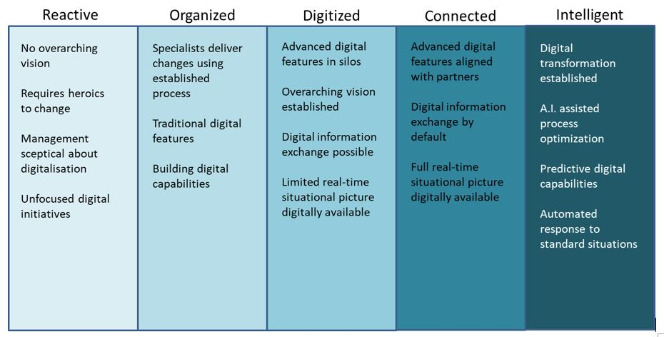
- Digitalisation Levels defined for Inland Waterway domain.
The whole maturity model in Figure 1 is set above the purely analogue environment, where voice communication via analogue (radio) communications means and data storage on paper prevail.
As a rule, an entity can only achieve a higher digitalisation level when all prerequisites or requirements from a lower digitalisation level have been accomplished or fulfilled respectively. That does not imply that for example the whole organisation needs to fulfil the features of that digitalisation level. Only the parts of the entity relevant for digitalisation and therefore for the assignment of the digitalisation level need to conform to the features of that same level. Those relevant parts should be indicated. Further explanations and examples of digitalisation levels presented in Figure 1 can be found in APPENDIX 1.
The highest digitalisation level Intelligent would mean that:
- the digital transformation has been completed (for all its parts relevant for digitalisation);
- Artificial Intelligence and Machine Learning assist in the optimisation of processes related to waterway provision, operation and maintenance as well as in the optimisation of vessel navigation processes;
- prediction algorithms are in place to support waterway and vessel navigation processes; and
- automatic responses are implemented to standard waterway provision, operation and maintenance processes as well as vessel navigation processes.
However, this goal might not be achievable within a short time frame and/or with the technologies available within near future. Hence, it is necessary to also use the other digitalisation levels as intermediate states of the digital transformation. For simplicity of reference, the following abbreviations to the different digitalisation levels may be used:
- Intelligent III
- Connected II
- Digitised I
- Organised 0+
- Reactive 0-
Presently, the digitalisation levels Reactive and Organised can be frequently found and thus form the baseline, where a limited number of digitalisation processes have partly become effective and form the starting point for any (future) increase of digitalisation maturity. The higher digitalisation levels are therefore abbreviated with Roman numerals above zero.
The term Waterway domain may be used as an umbrella term that designates the composition of several entities that interact in order to achieve their intended purpose and meaning. Applying the above digitalisation level model to the Waterway domain applies it to all the entities it is composed of (e.g. vessels, waterway field infrastructure, organisations providing services, and data objects for exchange). Each entity in the domain will have a digitalisation level both in general as a generic object and when considering individual instances of these entities (Figure 2).

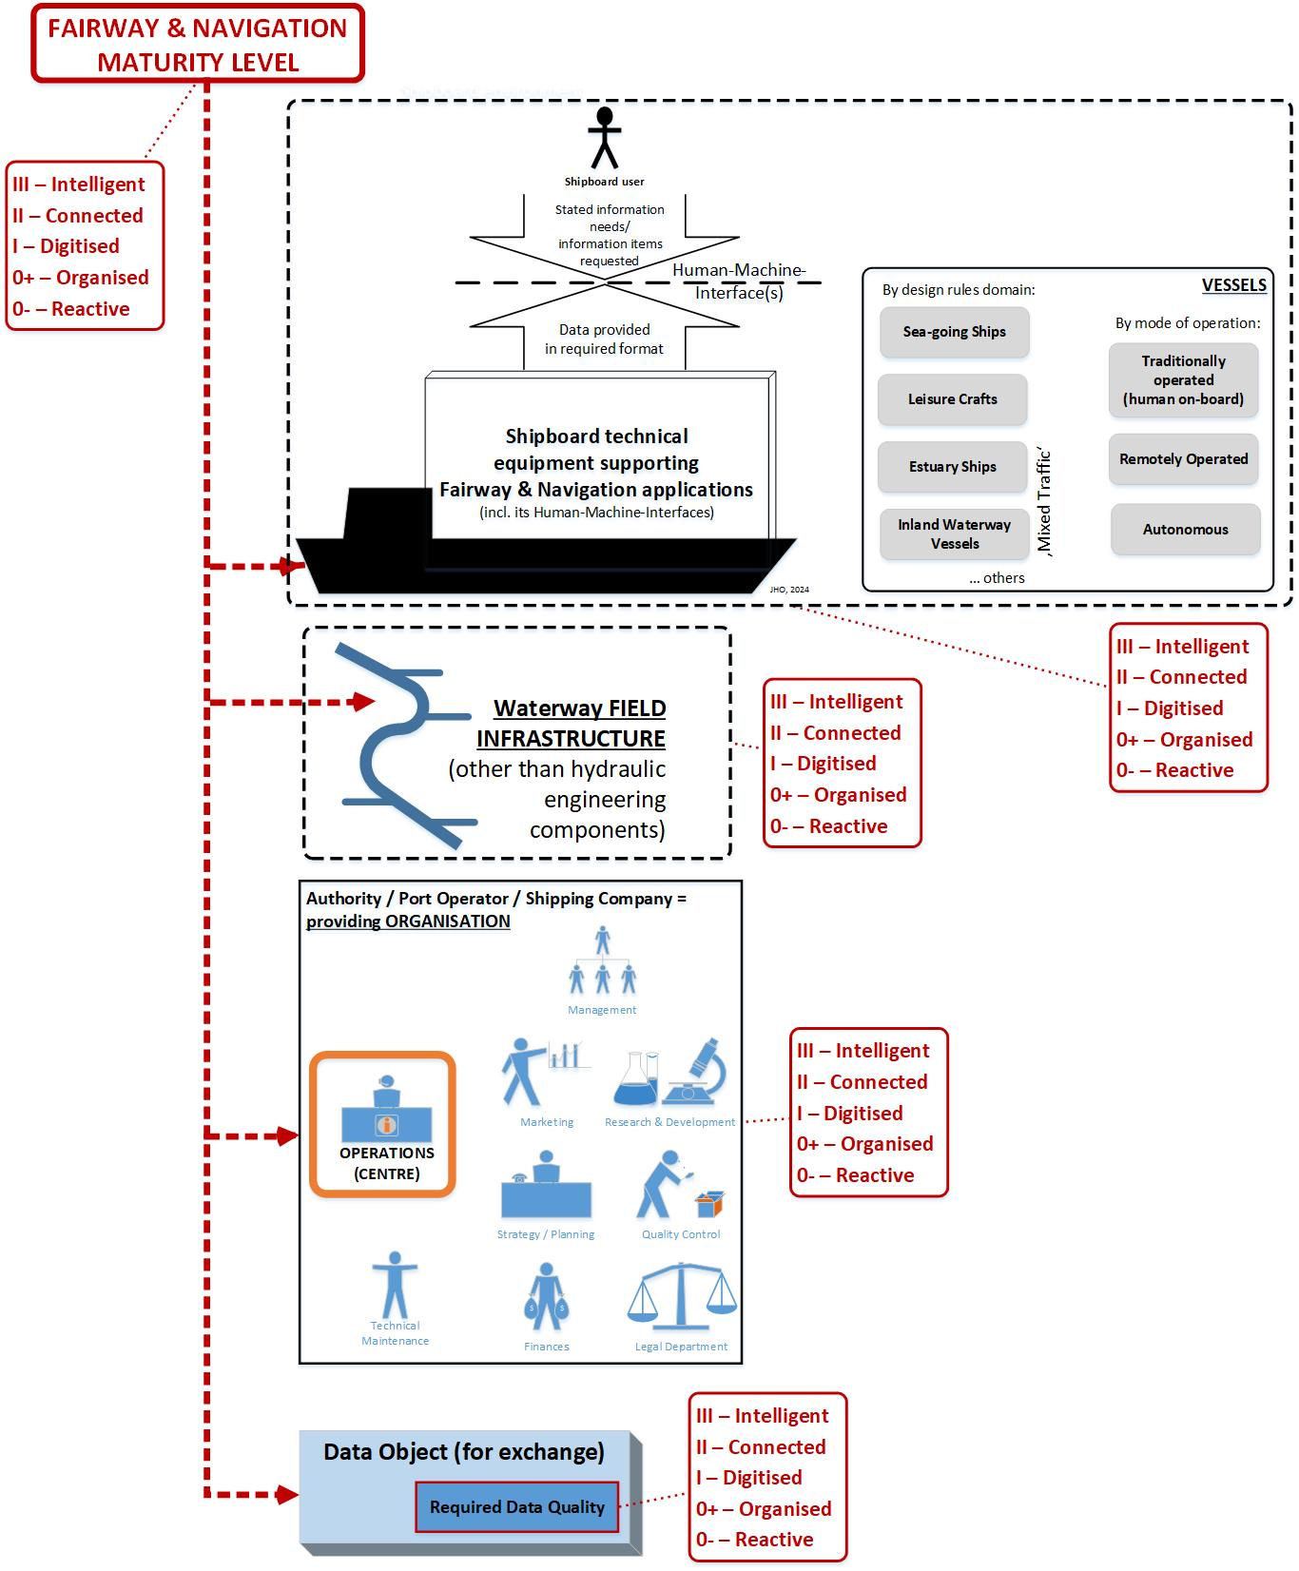
- Digitalisation levels applied to generic entities of the Waterway domain.

Digitalisation Challenges

Increased interdependency
There are certain important implications associated with increased digitalisation of the waterways domain that will need to be considered. The use of maturity model helps to identify possible problem areas related to for example the following topics:
- Regulations, operational procedures, terminology and data models
- Increased variety of data exchange interfaces
As opposed to the analogue domain, data exchange by digital technologies generally do not allow ambiguities in data object definitions and in data models governing these data objects. The necessary disambiguation needs to start with the data object definitions and data models. This in turn may prompt the need to remove ambiguity from operational procedures governing the interaction concepts as well as from regulations governing the operational procedures. This process needs to be done to the extent induced by the desired digitalisation level. For arriving at digitalisation level Connected where the digital exchange of data is the default situation, basically all relevant regulations, operational procedures, terminology and data models need to be free of ambiguities, as far as possible.
Another related consequence of the increase of digitalisation level is the increased variety of digital technologies employed to exchange data. Data exchange requires a terminal such as a transceiver on each side of the communication link to accomplish its communication task. Both terminals need to work together in accordance with a pre-defined set of rules such as data object encoding and link protocols governing the digital data exchange processes, and in the case of radio communication radio frequency usage rules. The opposite of this would be a technology that does not rely on the co-operation of any other entity to perform its task (e.g. radar).
In addition to the desired benefits, the increased digitalisation level also brings with it the disadvantage of increased interdependency. To mitigate this disadvantage, certain stand-alone technologies are still needed for fallback arrangements even with the advent of the highest possible digitalisation levels.

Match-principle
Entities, which have one or several operational relationships between them need to demonstrate the same digitalisation level. This requirement is called the Match-principle. The digitalisation level mismatch is a situation where different entities engaged in the same operational relationship(s) would not only be unable to use the benefits offered by the entity with the higher digitalisation level but may result in a more severe situation where the necessary operational relationship may not even be established. The mismatch situation may occur for example in areas where waterways with different types of service portfolios merge.
To follow the Match-principle and thus avoid digitalisation level mismatches is relevant especially during implementation and deployment. It is important to note, that in the digital domain, there does not automatically exist a graceful degradation of the service like in the analogue domain. This may in some cases lead to dropping from the intended digitalisation level to a very low digitalisation level. Any graceful degradation mechanism needs to be separately designed embracing all relevant entities and operational relationships. The following questions should be considered:
- What digitalisation level match margin would be permissible between which specific entities engaged in which specific operational relationship(s)?
- What would be permissible digitalisation level degradations in regular case operations?
- What would be permissible or anticipated fallback arrangements for exceptional conditions?
It needs to be noted that any digitalisation level mismatch will demonstrate its impact only during implementation and deployment, not necessarily when discussing regulatory, operational, and technical aspects in general during planning phase unless specifically taken into consideration. It is therefore advised to carefully study the implications of the Match-principle early on and act upon findings accordingly.

Mixed Traffic conditions
The mixed traffic scenarios constitute challenges for the digitalisation of waterways. The Figure 3 illustrates the mixed target fleet in generic categories on the left-hand side. There are specific legal/regulatory bodies defining what a vessel of a certain design rule domain should consist of and carry, subject to a carriage requirement. On the right-hand side, the relevant generic shore entities are shown such as waterway field infrastructure, including AtoNs, and different shore-based centres. While most of this mixed traffic has been present in the analogue world for long, the projection of these different (generic) entities into the digital domain (by means of e.g. data modelling) requires specific attention.

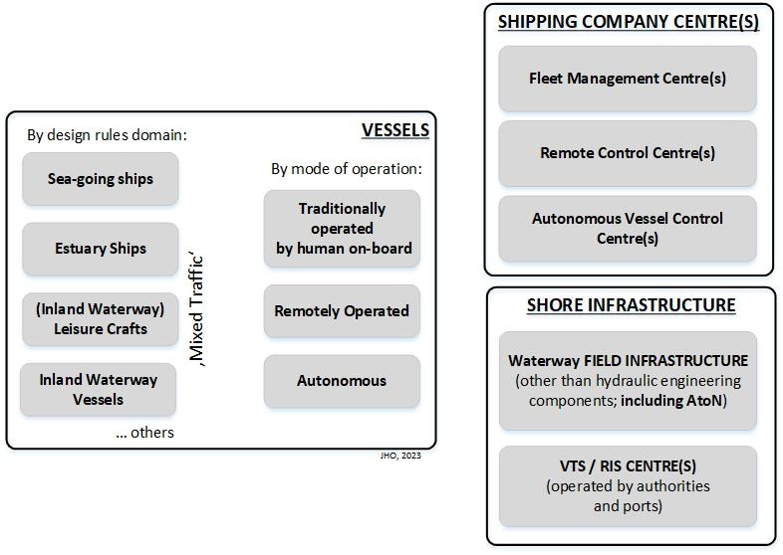
- Overview of generic mixed target fleet and different generic infrastructures and centres provided by shipping companies and shore authorities [7].

Vessels vs Waterborne Vehicles
There is a basic difference between vessels (defined by their purpose of carrying cargo and/or persons) and other waterborne vehicles (all other purposes) that needs to be considered related to digitalisation and especially to the Match-principle. IMO can agree on the mandatory carriage requirements for vessels, but not for all waterborne vehicles. This constitutes a mixed traffic that needs to be considered when planning digitalisation in the Waterway domain.

Automation and Autonomy
With the advent of highly automated and even autonomous vessels and their consideration at IMO using the technical term of Maritime Autonomous Surface Ships (MASS), IALA has engaged in the impact on Marine AtoNs early on. The key findings of an IALA workshop on ‘Marine Aids to Navigation in the autonomous world’ in 2021 [8] are highly relevant for the digitalisation of waterways:
- “Marine Aids to Navigation will continue to be essential infrastructure for all degrees of maritime autonomy on vessels and will continue to be required to support safe, efficient and pollution free transits. This includes identifying options for position, navigation and timing (PNT). This may lead to the development of adaptive AtoN to support different degrees of autonomous vessels.
- MASS will require a robust and resilient communication ‘system of systems’ to support complex and vital communication needs, allowing communication between ships, remote control centres, VTS, AtoNs and other elements that may be required in a MASS operating environment.
- All developments in the provision of AtoN to support MASS must consider their role in a mixed maritime environment which includes both conventional vessels and MASS and be fully compatible with both.”
These findings will however raise some further questions to be considered by IALA members:
- Would the communication between autonomous vessels and AtoNs be visual or (digital) radio communications or maybe both?
- What would be the requirements for an AtoN providing PNT to a full autonomous vessel?
- How would an automation supportive, autonomous vessel compatible, traditional AtoN appear and what would be its visual and electronic interfaces towards an automated vessel and even to an autonomous vessel?
- What degrees of shipboard automation would the same AtoN be capable of supporting?
- Could the mixed target fleet requirement only be fulfilled by an AtoN service portfolio of different, partly new AtoN services?
- And if so, how would an AtoN service portfolio look like that comprises different varieties of AtoN services that operate concurrently, with each individual AtoN service only addressing a certain portion of the mixed target fleet?
Different terminology domains and a variety of scales for describing the degree of automation or the degree of autonomy have been developed [9][10][11][12][13]. In a philosophical sense, there is no such thing as a degree of autonomy, since the entity under consideration either is autonomous or not. Therefore, the notion degree of automation with autonomy as its final stage would maybe be preferred.
ISO [9] draws attention to the temporal or to the process character of autonomous vessel autonomy. Autonomy is confined to a period and/or to a defined operational scope, that is called the Operational Envelope. It likely will be required that autonomous vessels are subject to a constant Autonomous Vessel Monitoring & Contingency Response functionality performed at an Autonomous Vessel Control Centre in order to navigate autonomously. As part of the contingency response, an autonomous vessel may fall back to become a remotely operated vessel or even a vessel traditionally operated by a crew on-board.
Further, ISO has defined the term autonomous ship system to indicate that each autonomous vessel needs to operate in an ecosystem comprising the support services and the remote-control services besides the autonomous vessel itself. In addition, ISO embeds the autonomous ship system within a wider context. On the shore side, this includes waterway services (e.g. tugs, anchorages), port services (e.g. mooring, cargo handling, supplies, inspections, reporting, checks), pilotage, waterway information (e.g. MSI and AtoN) and traffic services (e.g. VTS, RIS). The operational relationships between the various components of the autonomous ship system itself and between the autonomous ship system and its wider context imply an increased connectivity requirement compared to the present situation. These functional and physical links need to be established by a variety of communication technologies Figure 4 generically transforms the ISO statements into the overarching architecture for e-navigation where the position of the AtoN service of a waterway authority would be part of the Common technical shore-based system for fairway/waterway & navigation applications-box on the right hand shore-side.

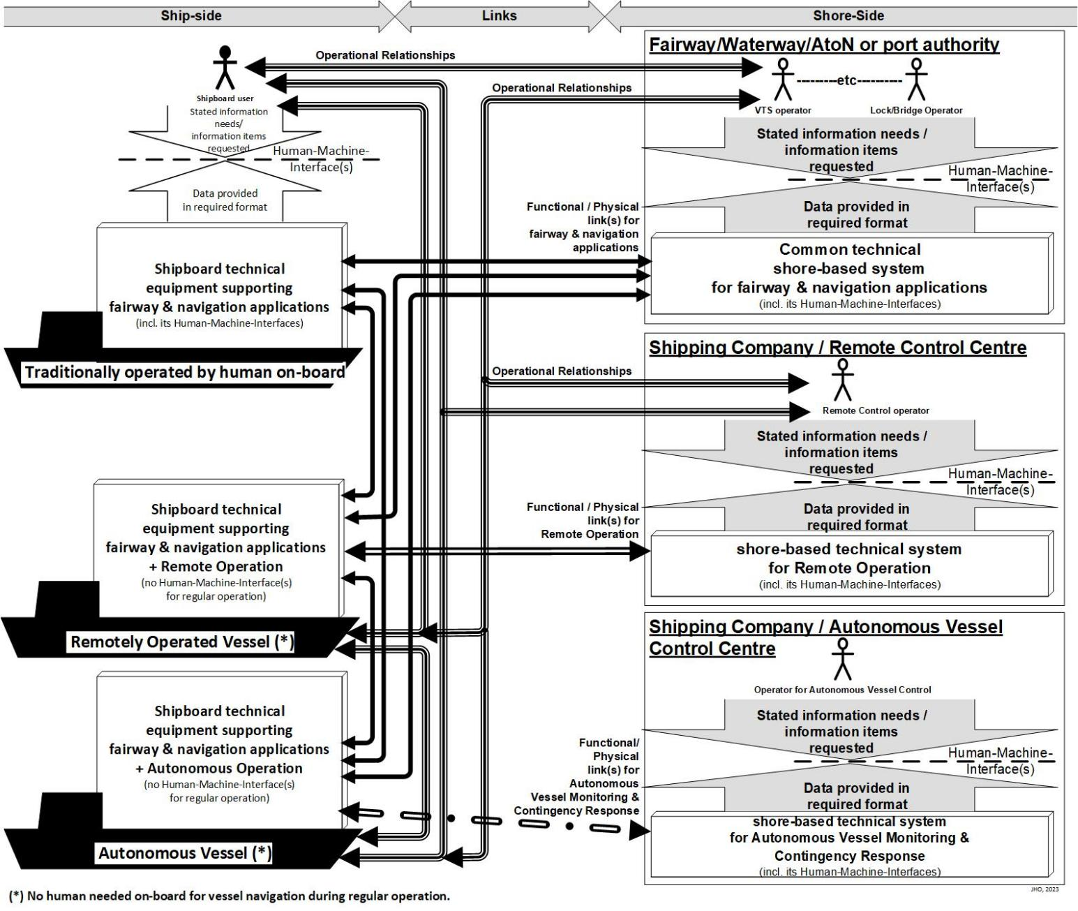
- Generic operational relationships and resulting generic communications relationships [7].

Mixed Traffic in Approaches, Inland Seaways and Estuaries
In several parts of the world, sea-going vessels operate frequently in inland waterways, for example when approaching ports via estuaries or during canal passages, and inland waterway vessels operate in coastal waters too. Further, the IALA defined system of AtoNs and the substantial relevant IALA recommendations and guidelines for its membership have been applied to both domains. Similarly, as an example of an IALA peer organisation, the World Association of Waterborne Transport Infrastructure (PIANC) also has this comprehensive perspective. A universally applicable terminology will facilitate an emerging internationally harmonised understanding of the advent of autonomous and remotely operated vessels in both the maritime and the inland waterway domains.

Digital model, shadow and Twin of waterway

Overview

A digital model is a digital representation of a physical object. Depending on the level of synchronisation between digital and physical objects, the digital representation can be also called digital shadow or digital twin (Figure 5).

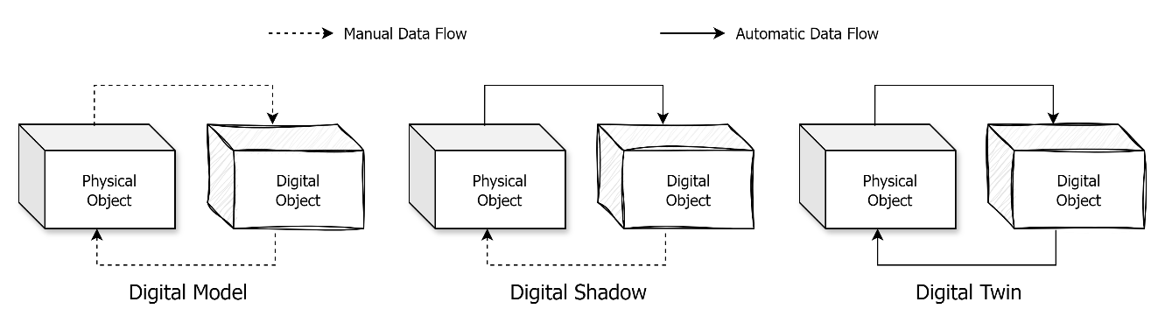
- Digital Model - Digital Shadow – Digital Twin [14].

The most basic digital model of a waterway includes information about the characteristics and maintenance events of a waterway as a comprehensive infrastructure entity and information related to specific waterway infrastructure components relevant for navigation and logistics in digital, reusable and preferably standardized format. It thus provides a comprehensive virtual representation of a physical waterway, including virtual representations of the specific physical waterway infrastructure components (e.g. AtoNs, VTS, radio communication and navigation means provided from ashore).
A more developed digital model, in addition, includes real-time waterway and/or individual infrastructure component information, observations on environmental conditions and information on vessel traffic: This type of digital model may be called digital shadow, and it would require appropriate sensors at, and communication means from its physical entities.
When the digital model is also capable of automatically providing feedback to its physical entities by appropriate communication means and decision-making algorithms it can be called a digital twin. A digital twin can be used for making real-time changes at its physical entities remotely initiated in the virtual domain. Hence, a digital twin becomes a tool for higher control processes in the virtual domain ashore, which in turn can be directed by (even automatic) evaluation of simulated future scenarios, forecasts and predictions.
A digital twin of a waterway and/or of its individual infrastructure components can be applied to support more optimized and predictive maintenance of individual waterway infrastructure components such as AtoNs (Figure 6). The digital twin within a given waterway can be applied to initiate any proactive corrective actions necessary to individual vessels or waterborne vehicles, to specific kinds of vessels, such as traditionally operated, remotely controlled or autonomous vessels, or to the vessel traffic in the context of that waterway and taking into account its prevailing conditions in real-time.
A comprehensive digital model of waterway will also provide valuable material for simulation tools that are used for the design and planning of waterways. The accuracy of any simulation tool results depends on the accuracy of the data it builds on. Simulation with accurate data can help to identify the risks, plan mitigation measures (e.g. proper channel layout and placement of AtoNs) and evaluate the mitigation results before deploying the plan. G1058, the Use of Simulation as a Tool for Waterway Design and AtoN Planning, provides guidance on the use of different simulation tools.
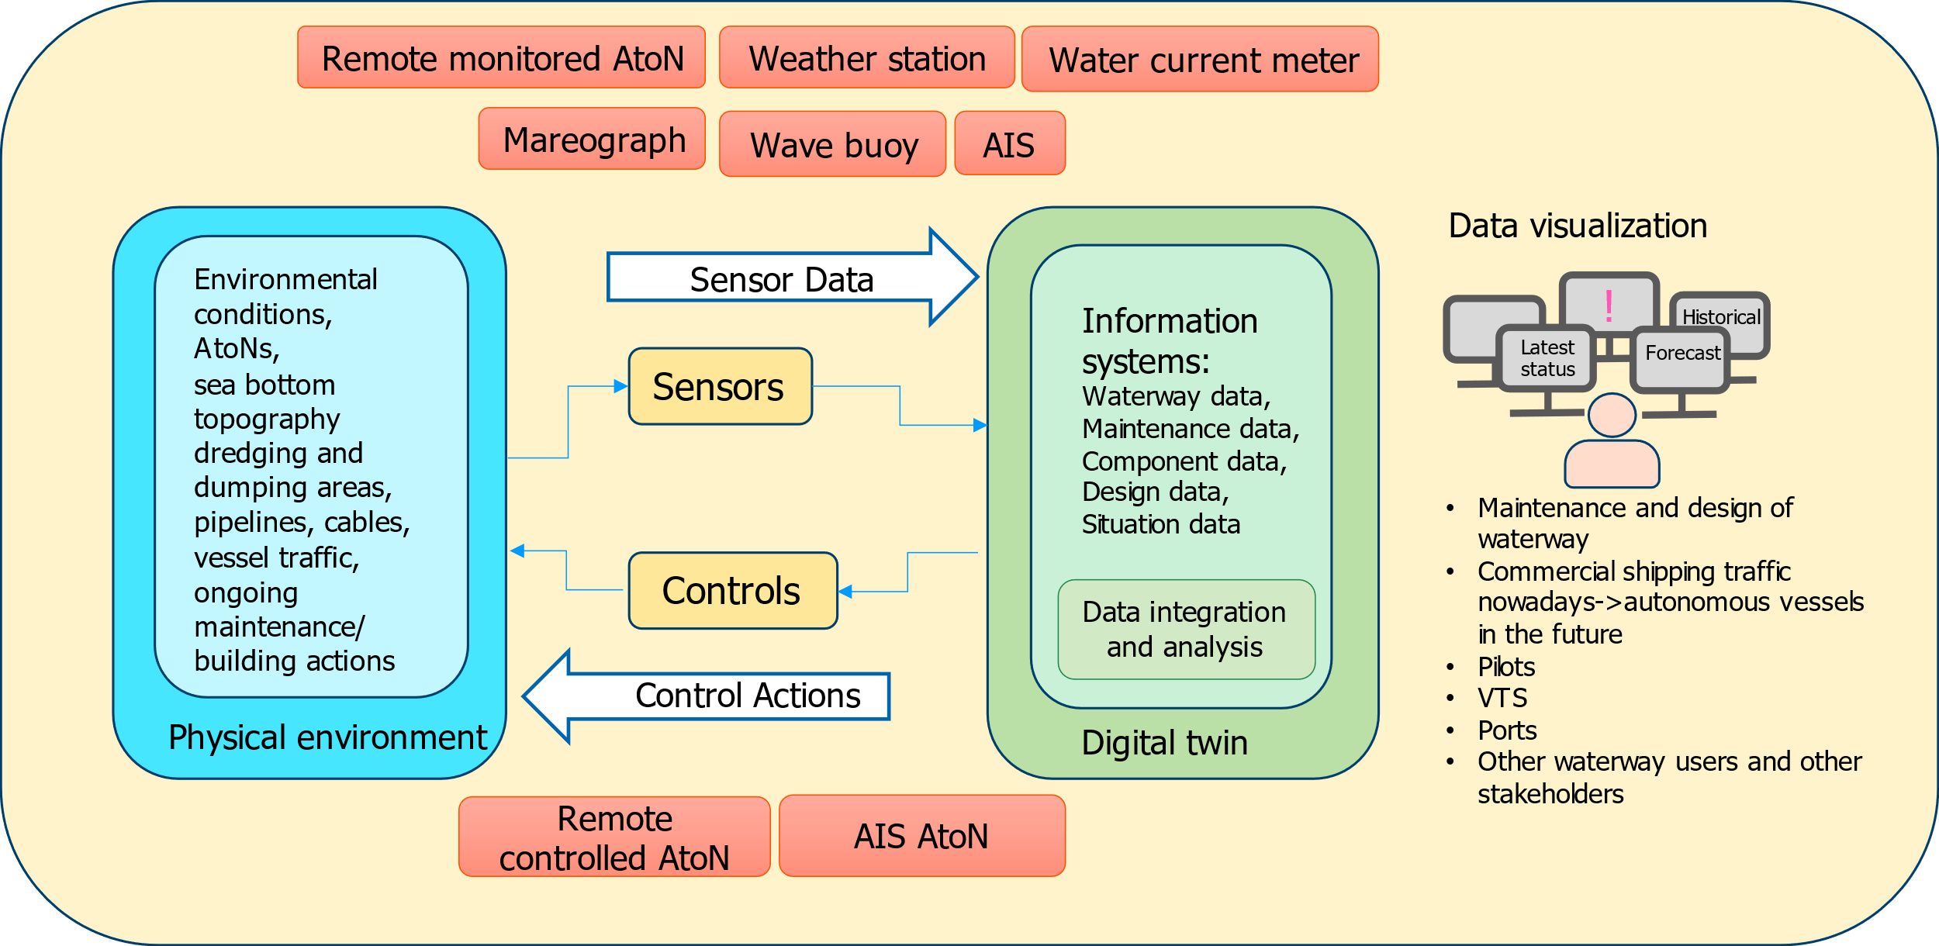
- Digital Twin in Waterway management.
From this introduction, it becomes clear, that digital twins are a feature of higher digitalisation maturity degrees, only.

Types of Digital Models

The waterway digital modelling can support two-dimensional, three-dimensional and multidimensional digital models.
Two-dimensional waterway digital model is based on symbols to abstract and summarize the real waterway, including waterway spatial data presented in two-dimensional (2D) waterway map (e.g. ENC), which cannot directly restore the real three-dimensional (3D) waterway.
The 3D digital model of a waterway can realistically reproduce the real environment of the waterway and its ports by using high-resolution remote sensing or aerial images combined with 3D digital models of buildings, docks, bridges and AtoNs, including not only the spatial information on the water surface, but also underwater and land spatial information, including seabed, terrain, docks, port buildings and bridges. However, the virtual elements of waterway such as equal depth area, no-sail area and anchorage area are not presented.
The multidimensional digital model of a waterway uses the 2D waterway map to make up for the shortcomings of the 3D waterway model. It merges the 2D and 3D spatial data to provide multi-dimensional, multi-resolution, accurate and rich geospatial information for digital waterway applications such as navigation, vessel traffic monitoring and AtoN telemetry and remote control.

Construction of Digital Twins

The digital twin may be developed in steps starting from the digital model. The process may include for example the following steps:
- Developing data management plan.
- Developing a geographic information system (GIS) to collect and display the information of various elements of waterways, ports and shipping hubs.
- Establishing the real-time weather and environmental condition monitoring network of waterway, with water level, depth, velocity and other factors to be considered. Create spatial data layers of these for display and monitoring purposes in the GIS.
- Establish the required communication infrastructure to allow two-way communication between physical waterway and its digital twin
- Using means of numerical simulation to establish the update iteration mechanism between sensor information and electronic waterway data to realize the development of digital twins of waterways.
- Creating forecast models to allow prediction of development of different phenomenon in the physical waterway.
- Integrating video surveillance system and other digital information to enrich the functions of digital twins of waterways.

Data Management Plan
Digital technologies do not allow ambiguities in data object definitions and in data models. Documented data management processes should be in place to secure the quality and correctness of data in every stage of the data life cycle and when processing and exchanging data.
The digital twin is relying on data from multiple static and dynamic sources with varying update rates. A data management plan is an important prerequisite for the construction of digital twins. It defines the criteria for data quality and thus determines the accuracy of the digital twin that can be reached. A data management plan may for example include the following rules for data, its flow and processing:
- Data is stored in information systems and data flows are automated (no points including manual work).
- Position information includes x, y and z-coordinates.
- Objects have geometry (e.g. point, line, polygon).
- Processing of data is documented.
- Quality of data is known and documented.
- Origin of data is known (authentication).
- Data is structured and data models are described or follow standards (including semantics, datatypes, accepted values, etc.).
- Data includes a timestamp, and history is maintained (not overwritten).
The digital twin introduces new possibilities to use data analytics tools, machine learning and artificial intelligence. An advanced digital twin may combine and analyse data in a way not designed by humans. It may also initiate actions based on the results of these analyses. This increases the need to strongly secure the quality and reliability of data (e.g. accuracy, integrity, immutability and origin) in every stage of the data life cycle and when processing and exchanging data.
Regardless of the status of data (e.g. in transit, at rest or being processed) it needs to be secured against cyber-attacks. G1182, Cyber security specifics from an IALA perspective, provides guidance on possible measures to mitigate cyber security risks in the IALA domain.

Information Presentation System
After processing the collected digital waterway data, a system for displaying the information is required. The presentation system features and functions may include but are not limited to the following:
Features:
- Friendly interface
- Easy to operate
- Efficient and stable
- With good openness and scalability
Functions:
- Waterway management
- Waterway maintenance
- Dynamic monitoring
- Information push

Sensor network
[maybe some material from section 6 added here]

Connectivity
Digitalisation of waterways is strongly dependent on the availability of adequate connectivity between all actors involved (e.g. vessels/waterborne vehicles, field infrastructure like AtoNs, land-based centers). IALA has published comprehensive guidance on communication technologies for maritime purposes.
The Guideline G1179, an Introduction to the Internet of Things from an IALA Perspective, provides information on communication systems for IoT which can be used to support the communication needs of digital twins of waterway infrastructure.
IALA MARCOM manual provides information on current, developing and future communication systems supporting communication between vessels and shore. These systems are relevant when planning the provision of digital services to vessels. While the provision of digital services increase, the legacy maritime communication systems (e.g. AIS, GMDSS) will need to be complemented with other communication systems which can better support transmission of larger amounts of data (e.g. VDES, satellite communication systems, IMT-2020). However, communication systems without mandatory carriage requirement cannot guarantee the connectivity to all vessels in the waterway alike.
[maybe some material from section 6 or from G1179 added here]

Maturity of Waterway digital Models

The digital maturity of waterway infrastructure information may be assessed using methods developed for digital twins. The assessment may be done in detail by multiple separate assessments dealing with different topic areas including for example the levels of convergence, capability or integration [4] or in more general terms. Maturity of digital twins is often described in five levels. The general maturity assessment for a single waterway could for example use the levels shown in Table 1.
- Maturity levels of digital twins.
Level 1 | Static, detailed or as-built twin (Digital model) | The digital model is based on planning and construction data, no direct connection exists between the physical entity and its digital representation.
Level 2 | Sensored twin (Digital shadow) | Sensors provide updated information about the state of the physical entity and the digital model is updated accordingly.
Level 3 | Responsive twin | The digital model can be used for providing response to changes in the physical entity via control functions.
Level 4 | Adaptive twin | The digital model is able to create simulations and forecasts.
Level 5 | Intelligent twin | The digital model is self-learning and capable of autonomous decision making.

Digital Services for navigation in waterways

Overview

The increase of provision of digital services to individual vessels or waterborne vehicles, to specific kinds of vessels and/or to vessel traffic at large is the major factor of any digitalisation of waterways. Some of the digital services may require bidirectional interaction with vessels or waterborne vehicles and some of the services may require that there is a real-time digital model, shadow, or even twin of the waterway already available.
Internationally harmonised or even standardised digital services would allow broad participation in a traditionally open system that waterways constitute. IMO, as an outcome of its e-navigation strategy [15], has defined certain set of digital services that operate in an overarching architectural framework, called Overarching e-navigation architecture. IALA has also defined certain digital services in support of IMO.
It should be noted, though, that the notion of digital services is not confined to those services defined by IMO or IALA, not even in the maritime domain alone. In proximity to shore, but in particular in harbour approaches and estuaries connecting to the hinterland via inland waterways a mixed traffic of various kinds of vessels/waterborne vehicles exists. This eventually results in portfolios of digital services provision beyond the scope of IMO alone, including for example also internationally defined River Information Services (RIS).
The users of digital maritime services mainly include vessels and relevant competent authorities. Digital service content may include but not limited to the following respectively.
Digital services provided to vessels or waterborne vehicles may include:
- real-time and accurate anchorage information, including anchorage operation information to help ships better arrange voyage plans;
- real-time and accurate hydrologic and meteorological information to assist ships make better operational decisions and reduce navigation risks;
- the best route for ships, based on real-time and dynamic ship flow, hydrologic and meteorological information, anchorage etc., to improve ship navigation efficiency and reduce the costs of shipping industry.
Digital services provided for relevant competent authorities to support decision making may include:
- For management departments in charge of ports, waterways, and AtoNs, the operation status of various types of AtoN infrastructure might be monitored in real time through telemetry, remote control, CCTV, etc. At the same time, the management of various kinds of AtoN infrastructure would be realized through the application of specific digital models.
- For management departments in charge of ports, waterways, and AtoNs, corresponding conclusions targeting to different demands as well as data support would be made through big data processing and analysis based on various kinds of information and statistics obtained, in order to assisting the decision-making on waterway planning, designing and maintenance and allocation of AtoNs.
- For pilot departments, the optimal boarding time and boarding location might be formulated according to the acquired real-time wind, wave, current data to effectively reduce the boarding risk.
- For maritime administrations, the best voyage plan might be developed by technical processing of the obtained dynamic data of various waterways, together with the comprehensive consideration of factors such as anchorage, port, ship flow, and weather to improve the utilization efficiency of anchorages and terminals. Furthermore, for emergency cases at sea, relative information would be acknowledged instantly, and emergency response would be conducted in time.

Digital services for Waterways as defined by IMO

IMO Circular letter MSC.1/Circ.1610, adopted by the IMO Maritime Safety Committee at its 101st session and amended in June 2024 [16], describes 16 types of maritime services in the context of e-navigation (Table 2). Compared to the previous version of the document the new version of the document adds the definition of AtoN service.
- Maritime Services in the Context of e-Navigation.
Maritime Service ID | Description
MS 1 | Vessel traffic service
MS 2 | Aids to navigation service
MS 3 | (Reserved for future use)
MS 4 | Port support service
MS 5 | Maritime safety information service
MS 6 | Pilotage service
MS 7 | Tug service
MS 8 | Vessel shore reporting
MS 9 | Telemedical assistance service
MS 10 | Maritime assistance service
MS 11 | Nautical chart service
MS 12 | Nautical publications service
MS 13 | Ice navigation service
MS 14 | Meteorological information service
MS 15 | Real-time hydrographic and environmental information services
MS 16 | Search and rescue service

IALA defines an AtoN as a device, system or service, external to vessels, designed and operated to enhance safe and efficient navigation of individual vessels and/or vessel traffic. The purpose of the Maritime Service 2, AtoN service, is to provide information not available on the nautical charts (e.g. new hazards, temporary shipping lanes, temporary areas to avoid, hydrological changes, polar region, ice areas) and to provide real-time PNT and PNT integrity information.
The Maritime Safety Information (MSI) service, Maritime Service 5, is an internationally and nationally coordinated broadcast network containing notices to mariners, weather warnings, weather forecasts and other emergency safety information.
Water level information, Maritime Service 14, is essential for the determination of under-keel clearance required for safe navigation. Forecasted and real-time water level information is important for applications such as route planning, port entry and the determination of tidal prediction. Real-time tide and water level information can be used for activities such as situational awareness, hazard avoidance, installation of offshore renewable energy facilities and route planning.

Digital services for Waterways as defined by PIANC

In order to improve the competitiveness of inland shipping and strengthen the seamless connection between water transportation and other modes of transport, the European Union utilize modern information technology to provide collaborative information services for users of various links of inland shipping.
The European Union has developed River Information Services (RIS), standardized the relevant technologies of RIS, and legalized the implementation of RIS, providing a basis for the final promotion of RIS to the pan-European scale. The EU implemented the RIS enabled Corridor Management Execution (RIS COMEX) project from 2016 to 2020, which covered 13 European countries and 14 partner companies. The objective of the project was to implement and operate cross-border river information services based on seamless data business exchange, building on existing national infrastructure and services. By developing a common approach to transport management and traffic management among European stakeholders, the project was an important step towards a clear and unified vision for the management of European water transport corridors.
The World Association for Waterborne Transport Infrastructure (PIANC) has, in analogy with IMO, identified a set of operational use cases with related services to support safe, secure, efficient and environmentally friendly inland navigation [17]. The identified services are dived in two categories; services related to traffic and services related to transport in general. The identified services are introduced in Table 3 below.
- Operational River Information Services (RIS) defined by PIANC.
Operational service | Description
Traffic related
Fairway information Services (FIS) | Supporting planning, executing and monitoring the voyage. (e.g. geographical, hydrological and administrative information regarding the waterway and its infrastructure).
Traffic information Services (TIS) | Supporting the safety and efficiency of traffic and navigation on inland waterways. (e.g. vessel positions, specific vessel information, types of cargo).
Information to support Traffic Management (TM) | Supporting VTS, lock and bridge management and traffic planning.
Information to support Calamity Abatement (CAS) | Supporting actions necessary to limit the consequences of calamity, accidents and incidents.
Transport related
Information to support Transport Logistics (ITL) | Supporting transport logistic processes in inland navigation (e.g. voyage planning, transport management, port and terminal management, cargo and fleet management).
Information to support Law Compliance (ILC) | Facilitating legal compliance for the waterway users and supporting the relevant agencies responsible for inland navigation law enforcement.
Information to support Statistics (ST) | Supporting statistical processes (e.g. information on traffic and transport in inland navigation).
Information for Waterway Charges and Harbour Dues (CHD) | Facilitating the calculation and collection of waterway charges and harbour dues.

Each Operational River Information Service (RIS) in Table 3 provide the users with a set of information elements relevant for the operational use case. The information elements cover the following general information categories:
- Fairway and Infrastructure
- Fairway related (e.g. depth profiles, water level and weather information, AtoNs, traffic rules)
- Land related (e.g. harbour areas, lock schedules, vertical clearance of bridges)
- Vessel
- Dynamic data (e.g. position, speed)
- Hull information (e.g. vessel identification data, certificates)
- Vessel convoy related (e.g. convoy type and characteristics)
- Voyage and cargo
- Location related (e.g. destination, estimated time of arrival)
- Cargo related (e.g. origin and destination of cargo, details of dangerous cargo, number and type of containers)
- Persons on board related (e.g. number and details on persons onboard)
- Traffic
- Object related (e.g. number of vessels at berth, lock door status, average locking duration)
- Waterway section related (e.g. average traffic density, sailing time)

S-100 data products and technical Services

The maritime digital services, including the 16 Maritime Services defined by IMO, are based on exchange of standardized data products via communication links in standardised and structured way. This may be described via the Service - Data - Connectivity stack.
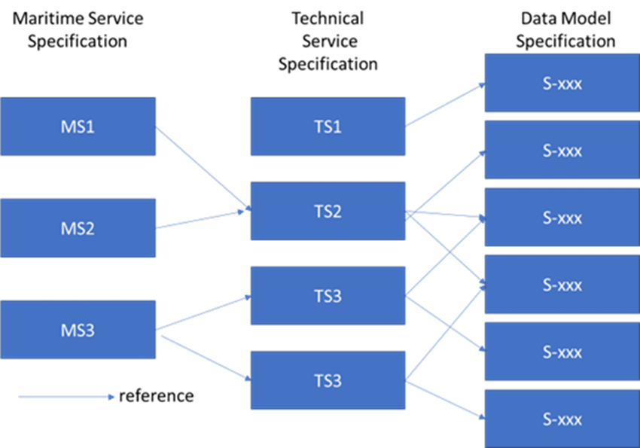

- The relationship between specifications of Maritime Services, Technical Services and S-100 data models/product specifications [and connectivity].
The International Hydrographical Organization (IHO) is maintaining a registry of standardized S-100 data model specifications which form the basis for the 16 IMO Maritime Services Figure 7. The data model specifications enable the digital representation of the navigable waters in terms of for example detailed seabed topography, ocean currents, weather forecasts, local tides, water level simulations, navigational warnings and harbour information. A digital shadow of the waterways, supporting the safe and efficient navigation, can be provided to mariners via S-100 products.
IHO has the main responsibility of the development and maintenance of S-100 data model specifications that are used for vessel route planning and monitoring. Other supporting data model specifications are being developed by other international organisations (Table 4). Starting from 2026, S-100 data products can be used in vessels ECDIS equipment and IHO has identified the first set of products that will be allowed to be portrayed in ECDIS. These five products have been indicated in Table 4 using bold text.
The S-100 products need to be updated in different update intervals depending on the type of the information they contain. Many new S-100 products will presumably be distributed via the existing Regional ENC Coordinating Centres (RENC) in the same manner than current ENC products. However, some S-100 products will carry near real-time information and other distribution channels need to be considered. IALA has been actively involved in developing technical service specifications for interfacing the frequently updated, near real-time S-100 data products like S-212 VTS Digital Service.
The current list of S-100 product specifications registered to IHO registry is presented in Table 4.
- List of known IHO S-100 based product specifications
Responsible organization | Number range | Product specifications
International Hydrographic Organization (IHO) | 101-199 | S-101 Electronic Navigational Chart (ENC)  S-102 Bathymetric Surface  S-103 Sub-surface Navigation  S-104 Water Level Information for Surface Navigation  S-111 Surface Currents  S-112 Open - (See Decision HSSC9/38)  S-121 Maritime Limits and Boundaries  S-122 Marine Protected Areas  S-123 Marine Radio Services  S-124 Navigational Warnings  S-125 Marine Aids to Navigation (AtoN)  S-126 Marine Physical Environment  S-127 Marine Traffic Management  S-128 Catalogue of Nautical Products  S-129 Under Keel Clearance Management (UKCM)  S-130 Polygonal Demarcations of Global Sea Areas  S-131 Marine Harbour Infrastructure  S-164 IHO Test Data Sets for S-100 ECDIS
International Organization for Marine Aids to Navigation (IALA) | 201-299 | S-201 Aids to Navigation Information  S-210 Inter-VTS Exchange Format  S-211 Port Call Message Format  S-212 VTS Digital Service  S-230 Application Specific Messages  S-240 DGNSS Station Almanac  S-245 eLoran ASF Data  S-246 eLoran Station Almanac  S-247 Differential eLoran Reference Station Almanac
Intergovernmental Oceanographic Commission (IOC) | 301-399 | None proposed yet
Inland ENC Harmonization Group (IEHG) | 401-402 | S-401 IEHG Inland ENC  S-402 IEHG Bathymetric Inland ENC
WMO Service Commission (SERCOM) | 411-414 | S-411 Ice Information  S-412 Weather and Wave Hazards  S-413 Weather and Wave Conditions  S-414 Weather and Wave Observations
International Electrotechnical Commission - TC80 (IEC-TC80) | 421-430 | S-421 Route Plan
NATO Geospatial Maritime Working Group (GMWG) for Additional Military Layers (AML) | 501-525 | None proposed yet

Maturity of Digital Maritime Services

The aviation domain has since long defined categories for types of airport runways based on level of approach and landing capabilities provided to the airplane. This concept could be adapted to the waterway domain. The levels defined in the aviation domain are as given in the following table.
- Airport runway service categories [18].
Level | Description
Non- precision Approach Runway | A runway served by visual aids and at least one non-visual aid, intended for landing operations following an instrument approach operation with a minimum descent height or decision height at or above 75 m (250 ft).
Precision Approach Runway, CAT I | A runway served by visual aids and at least one non-visual aid, intended for landing following an instrument approach operation with a decision height not lower than 60 m (200 ft) and with either a visibility not less than 800 m or a runway visual range not less than 550 m.
Precision Approach Runway, CAT II | A runway served by visual aids and at least one non-visual aid, intended for landing operations following an instrument approach operation with a decision height lower than 60 m (200 ft), but not lower than 30 m (100 ft) and a runway visual range not less than 300 m.
Precision Approach Runway, CAT III | A runway served by visual aids and at least one non-visual aid, intended for landing operations following instrument approach operation with a decision height lower than 30 m (100 ft) or no decision height and a runway visual range less than 300 m or no runway visual range limitations.

By analogy, the role of a runway in aviation is represented in the maritime domain by the waterway. There can be digital services provided for shipping while passing through the waterway to a port. In the aviation domain in Table 5, these electronic services are the precision instrument approach and landing transmissions by the Instrument Landing Systems (ILS) provided at airports. Different levels of service provision in the waterway domain reflect, again by analogy, the different requirements of shipping for support in different types of waterways. In aviation, these different needs are the visual ranges available vertically and ahead for landing decision making, in the waterway domain, this translates to different sets of digital services provided, which in turn may indicate different degrees of digital maturity.
The maturity of digital services in Waterway domain could for example use the levels shown Table 6.
- Digital maturity levels of navigational services
Service level 1 | Basic AtoN services, no integrity information | Visual AtoNs and radar navigation aids, GNSS
Service level 2 | AtoN integrity information provided | Broadcasted AtoN status, GNSS integrity and augmentation, environmental information, etc.
Service level 3 | AtoN services adapted to existing conditions | AtoNs are manually adapted based on waterway conditions (e.g. visibility, traffic, water level)
Service level 4 | AtoN services adapted to individual user needs | Individualised services are provided to vessels
Service level 5 | Adaptation of services fully automatized | AtoNs are automatically adapted based on waterway conditions and individualized services are provided to vessels automatically.

Architectures for Digitalisation of waterways

Overview

The aim of any architecture is to structure the different entities within its scope into a contextual framework. They help to understand processes and data flows and identify possible gaps. Architecture thus provides both structure and context. Different architectural models highlight different points of view and thereby mutually complement each other. The need for architecture increases with the increase of digitalisation level and the resulting increase of co-operative interactions. Each of the individual technology-oriented architectures introduced in this section, if and when applied to the waterway domain, contributes to increasing the digitalisation level.

Datalink Communications Architecture

Each mode of transport shares the same fundamental architecture which includes mobile unit, infrastructure and the data links in between. This most fundamental architecture can be called a datalink communications architecture. It includes the full chain of the data flow from its ultimate source to its ultimate destination.
In maritime, datalink communications have been used for decades now. Familiar examples are the terrestrial Digital Selective Calling (DSC) technology included in the Global Maritime Distress and Safety System (GMDSS) and the Automatic Identification System (AIS).
In case of an emergency, a human member of the shipboard bridge team presses an alert button at a dedicated Human-Machine Interface (HMI), which initiates an emergency call via the DSC datalink communications to be displayed on another dedicated HMI at the receiving station (i.e. another ship or shore centre) to a human on the watch, who then may reply via datalink communications and/or voice and take further search and rescue actions, as appropriate.
Vessel AIS installation includes a dedicated mandatory HMI labelled Minimum Keyboard and Display (MKD) allowing for the full communication chain to be covered, at least in ship-to-ship AIS-datalink communications. There are initiatives to integrate the AIS data directly into vessels Integrated Navigation Systems (INS) in the future which would further enhance the usefulness of this datalink and allow for example to use the full potential of the AIS Application Specific Messages (ASM).

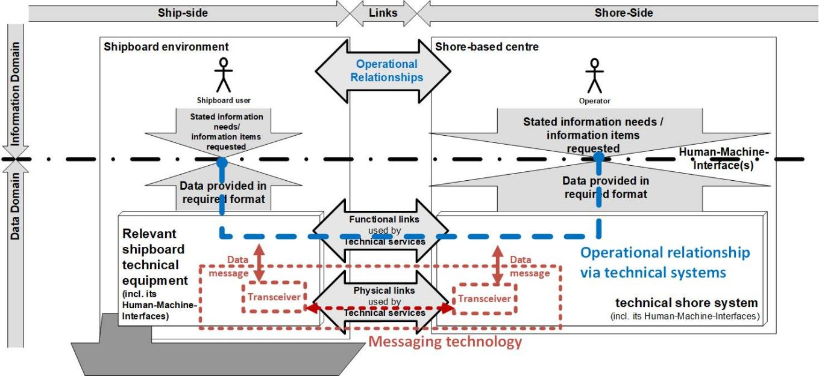
- Voice and datalink communications implied by overarching e-navigation architecture
With the advent of e-navigation, the long-established notion of maritime datalink communications has been generalised and made foundational to the overarching e-navigation architecture, including voice communications. Thus, the IMO adopted overarching e-navigation architecture is based on datalink communications architecture. The Figure 8 above illustrates the human-to-human datalink communications supporting the operational relationship (as functional links) via appropriate technical systems (as physical links), which in case of the datalink communications are certain messaging technologies, in combination with appropriate HMIs on both sides.
It is important to note, that the datalink communications architecture is carrier-agnostic, allowing the use of variety of different physical links as required or as available.

The Infrastructure Site Architecture

Infrastructure site architecture may be an option in confined waterway areas, where the distances between the infrastructure site (e.g. AtoN) and the vessel’s shipboard equipment can be considered as sufficiently short range. It can support at least the following three different use cases:
- co-operative position determination of the vessel passing by the infrastructure site, which is also electronically identified in the process;
- upload of data relevant for navigation from infrastructure site to vessel, such as locally gained sensor data or remotely received data for broadcast to all passing vessel or remotely retrieved data for identified vessel, if sufficient time available for retrieval process;
- download of vessel data to infrastructure site, such as vessel sensor data at the time of passing of the infrastructure site or data stored by the vessel on-board equipment for a period prior to passing by the infrastructure site.
The Waterway Infrastructure Site Architecture is illustrated by Figure 9 below.
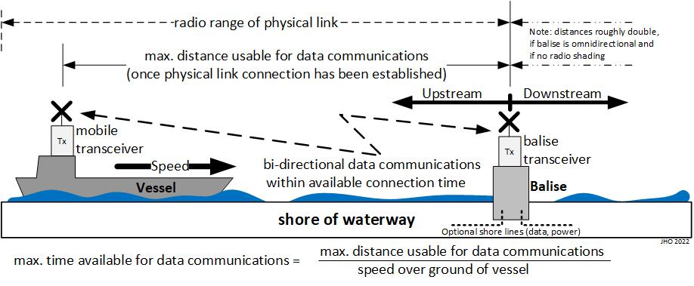
- Example of the use of Waterway Infrastructure Site Architecture.
In order to give an indication for timing requirements when selecting a suitable short range radio communication technology to support the Waterway Infrastructure Site Architecture’s use cases, the following example calculations (Table 7) for vessels of different speeds over ground at an example maximal distance usable for data communications are given.
- Example calculations for time available for data communications at Waterway Infrastructure Site Architecture
Max. time available for data communications from vessel to Infrastructure | Max. distance usable for data communications vessel to infrastructure | Vessel speed over ground
36 s | 100 m | 10 km/h = 2.8 m/s = 5.4 knot
10 s | 100 m | 36 km/h = 10 m/s = 19.4 knot

The System Interconnection Architecture

When it comes to multiple co-operative communication relationships operative simultaneously, as is regularly the case at any mode of transport, architectures for complex co-operative technical systems are needed to tackle the complexities involved.
The C-ITS System Interconnection Architecture [19], can be adopted with some amendments to the waterway domain, which could be called the Maritime System Interconnection Architecture (Figure 10).

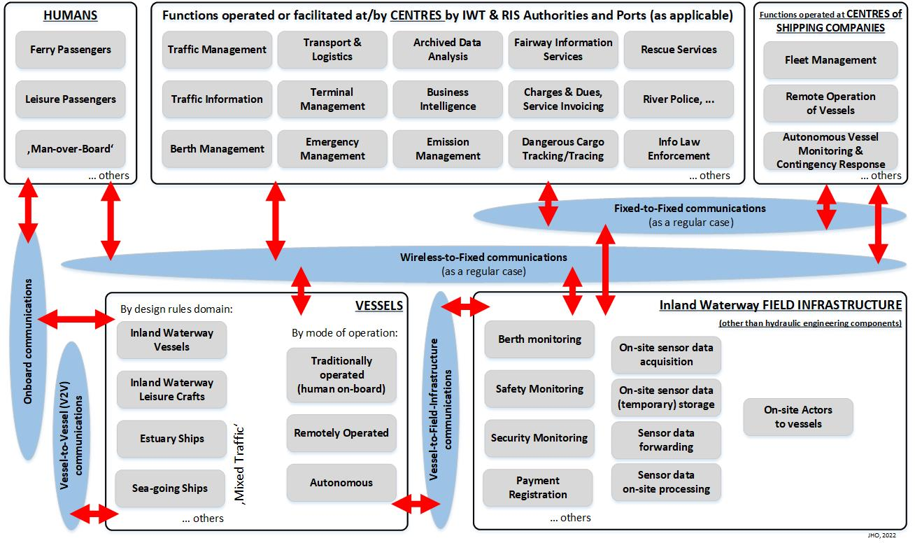
- Maritime System Interconnection Architecture.
The Figure 10 defines the following waterway communication domains:
- Vessel-to-Vessel (V2V) communications domain,
- On-board communications domain
- Vessel-to-Waterway Infrastructure communications domain,
- Wireless-to-Fixed communications domain, and
- Fixed-to-Fixed communications domain.
Using the interconnection architecture to study operational relationships supported by communications domains provides a powerful architectural means to create and justify useful and potentially even optimal combinations of communication technologies. It has the following benefits:
- By assigning every (digital) communication technology under consideration to one or more of the communications domains, the versatility of every (digital) communication technology or lack of it becomes apparent. It would allow to select for deployment the most versatile communication technology for one but potentially several communications domain(s) as long as all required functionalities can be provided.
- Datalink communications could use one or more functional link path(s) between the entities they connect, and, in addition, possibly act as relays. This would not only show the resulting need for interfacing, specification, and standardisation throughout their functional link path(s) but would also indicate potential fall-back routes for each datalink communication using different functional links and potentially entities acting as relays.
- Interconnection architecture once adopted by all relevant stakeholders of the waterway domain, may serve as a powerful community tool for harmonisation of the descriptions, definitions, specifications, and standardisation of the functional and the physical communication links, supporting the operational relationships between all entities involved.

The Overarching Waterway Domain Architecture

The fully developed overarching maritime architecture was developed related to IMO’s e-navigation initiative as shown in Figure 11 and it can be directly used in waterway domain. The two black boxes for the technical systems of the shipboard and of the shore-side are further investigated in this section.

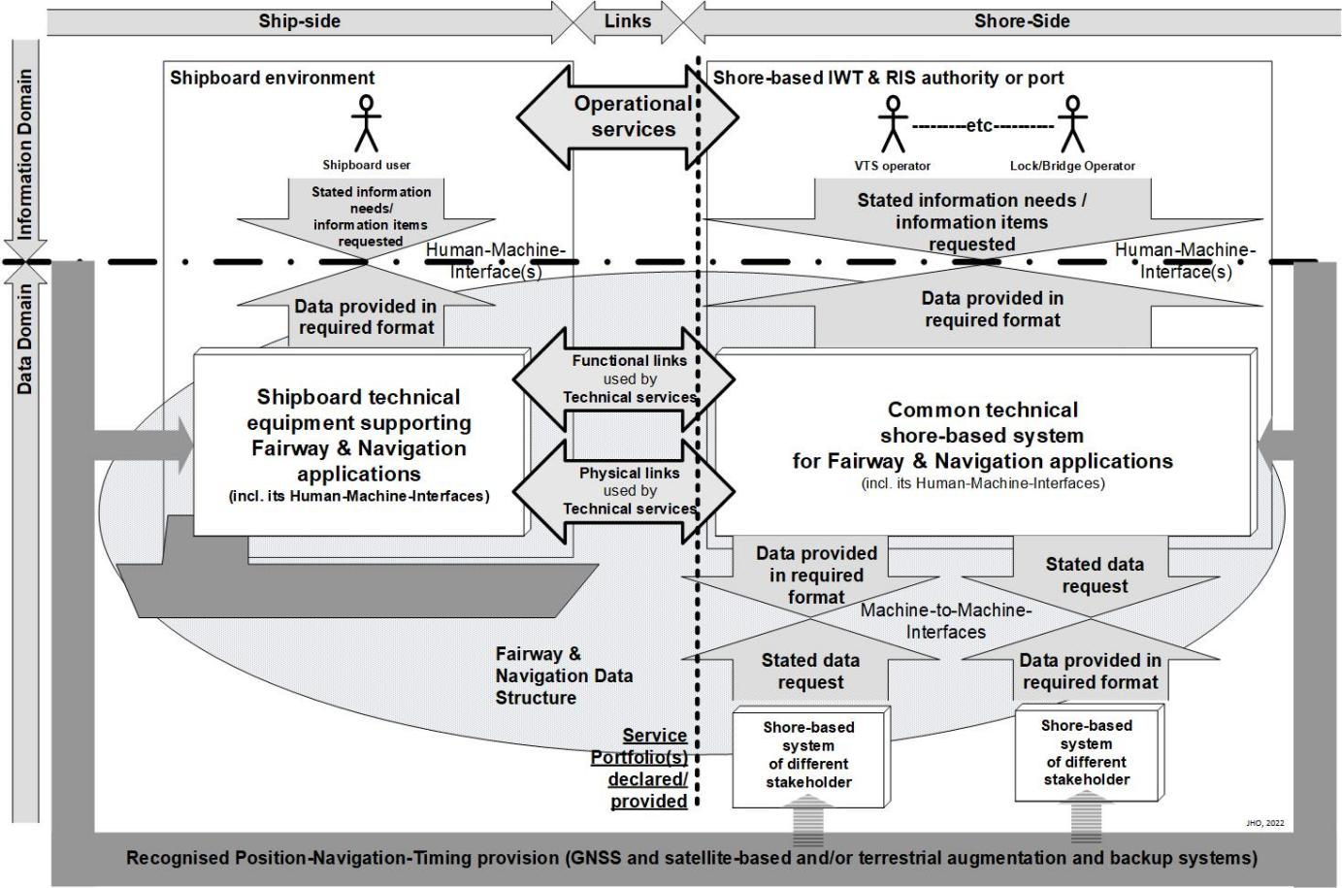
- Overarching Waterway domain Architecture

Shipboard Navigation System Architecture

Related to its e-navigation initiative, IMO has identified the need to ensure effective decision-making and safe navigation by the bridge team and the proper integration and presentation of information received. In full recognition of this, IMO, over the past two decades, has extensively addressed the harmonisation and standardization of a ship’s bridge layout in general, but also down to the harmonisation of symbols on navigational displays.
The generic shipboard navigation system architecture (Figure 12) is structured hierarchically in three functional layers in the vertical dimension, which are from bottom to top:
- Sensor / Source Layer: Including shipboard sensors, the pre-processing entities for their data and the radio communication front ends to the physical radio links. This layer provides the technical interfacing to the physical and operational environment of the ship.
- Data Processing Layer: Specialised in processing, storing, and retrieving data relevant for the navigation of the ship, including the selection, filtering, and routing of the available physical radio communication links as well as the handling of all relevant alerts from navigational systems but also from other bridge equipment as received from Bridge Alert Management (BAM).
- Operational Layer: This layer provides the HMI to the bridge team to support their navigational tasks as indicated.

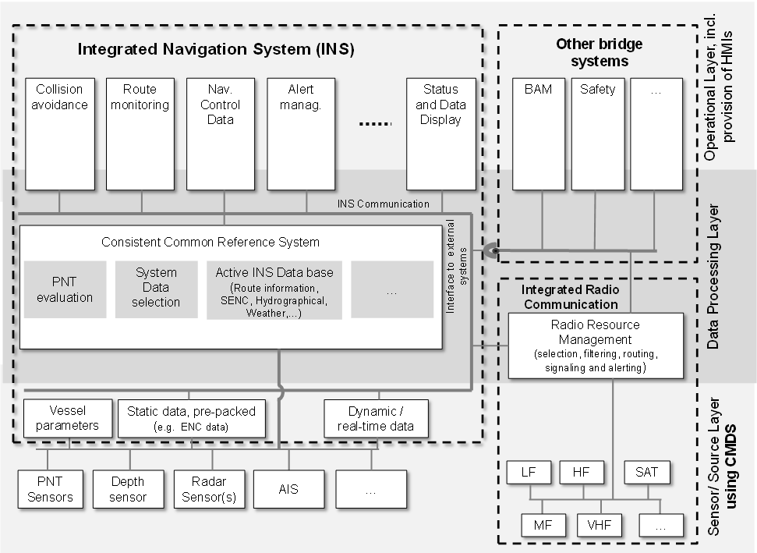
- Generic shipboard navigation system architecture in the context of e-navigation

The Common Shore-based System Architecture

As a consequence of the adoption of the overarching architecture for e-navigation by IMO, the need emerged to have an internationally harmonised eco-system for technical shore systems in place capable of seamlessly incorporating new functionalities stemming from e-navigation as well as operating and further developing classic services, while specifically taking into account the demands of long-term technical operation.
Hence, IALA started with the development of a Common Shore-based System Architecture (CSSA) both in a broad generic sense and in a sense of a more specific architectural solution [20][21]. IALA’s work in this regard support its members, most often national authorities, that deploy and operate shore systems or technical services ranging from visual aids-to-navigation via PNT and radio communication services to VTS and need to continue to do so even with increased digitalization and the advent of new technologies.
The necessary architectural framework is a three-layered service-oriented architecture geared towards the data/information flow implied by the overarching e-navigation architecture and therefore functionally similar to the three-layered shipboard navigation system architecture. The top-level structure of the CSSA is illustrated in Figure 13, where the arrows indicate data/information flow between its different functional components.

- Structural overview on Common Shore-based System Architecture (CSSA).
The four functional services of CSSA are:
- Data Collection and Data Transfer services: Interfacing with the waterway, including vessels, AtoNs and the physical environment.
- Value-Added Data Processing services: Pre-processing, evaluating and storing data. The data/information core of the CSSA.
- Gateway service: Allowing data to be exchanged with systems of other shore-based stakeholders and with any kind of external information and/or telecommunications or internet providers.
- The User Interaction Services: Providing the HMI to the primary users of the CSSA, namely those operators in centres operated by authorities that also operate the shore system.

The Maritime Architecture Framework

The previous architectural considerations focussed on technically oriented architectures with the intent in mind to provide places for new technologies to be plugged in seamlessly. However, technology and technical services employing them are always embedded in socio-technical systems. This leads to requirement for an additional architectural framework that would allow business, operational and technical perspectives of the waterway domain to be brought together within the socio-technical system background and allowing:
- targeted harmonisation of existing but potentially even conflicting documents which have often been developed by different stakeholder domains over a time period but have never before been brought into contact with each other;
- targeted development of missing documents to cover gaps.
The framework architecture provides a standardised methodology to analyse, design, compare and discuss different maritime IT-architectures and socio-technical systems, including related regulations within their (envisioned) maritime context, in a consistent and harmonised way. The framework architecture in general provides a means to overcome silos and identify overlaps or gaps within the socio-technical system under consideration and is thus required to achieve any higher digitalisation level than just digitised information.

RAMI cube framework architecture
The Reference Architecture Model for Industry 4.0 (RAMI) has been defined by the Industry 4.0 -initiative by bringing together previously existing IEC standards on Life Cycle Value Stream [22] and on Hierarchy levels [23][24] as two dimension in the RAMI cube, while the third dimension is represented by the different layers of interest.
The resulting three-dimensional architecture framework (Figure 14) is capable of capturing all relevant aspects (and their documentations) of even the most complex socio-technical systems, such as manufacturing industry, Smart Grid networks, and with some adaptation, also to the maritime transport domain.

- Representation of Reference Architecture Industry 4.0 as a RAMI cube.
The different dimensions of the RAMI cube have the following meanings:
- Hierarchy Axis: In the manufacturing industry, this axis shows the hierarchy from product, i.e. that entity the manufacturing industry bases its revenues on, up through various level of gaining even more control over the production process and its organisation to the enterprise level at large and even beyond into the (market) environment, which is expected to be connected, thus being labelled Connected World. This axis is similarly present in all domains, although with different number of levels potentially and also with different names to the levels most likely.
- Product Life Cycle Axis: This describes the product’s life cycle from the first idea to the phasing out. This axis it is the most domain specific. Therefore, it will be replaced by a different one once leaving the manufacturing industry for adaptation to a different domain.
- Layers of Interest: Allows to capture the exact positions where digitalisation hits. It shows, which layers will reside entirely in the digital domain, to the extreme of becoming digital twins, and which parts will always reside in the physical world only (Table 8).
- Compilation of meaning of the Layers of Interest.
Business | Organisation and business processes | Digital World
Functional | Functions of the asset | Digital World
Information | Necessary data | Digital World
Communication | Access to data | Digital World
Integration | Transition from real world to digital world | Digital World
Integration | Transition from real world to digital world | Real World
Asset | Physical things in the real world | Real World

Adaptation to Maritime Architecture Framework
The RAMI cube has been adapted to the maritime domain resulting in the Maritime Architecture Framework (MAF) [25]. The MAF cube represents characteristics of the maritime domain using the three dimensions, Hierarchical axis, Topological axis and Interoperability layers (Figure 15).
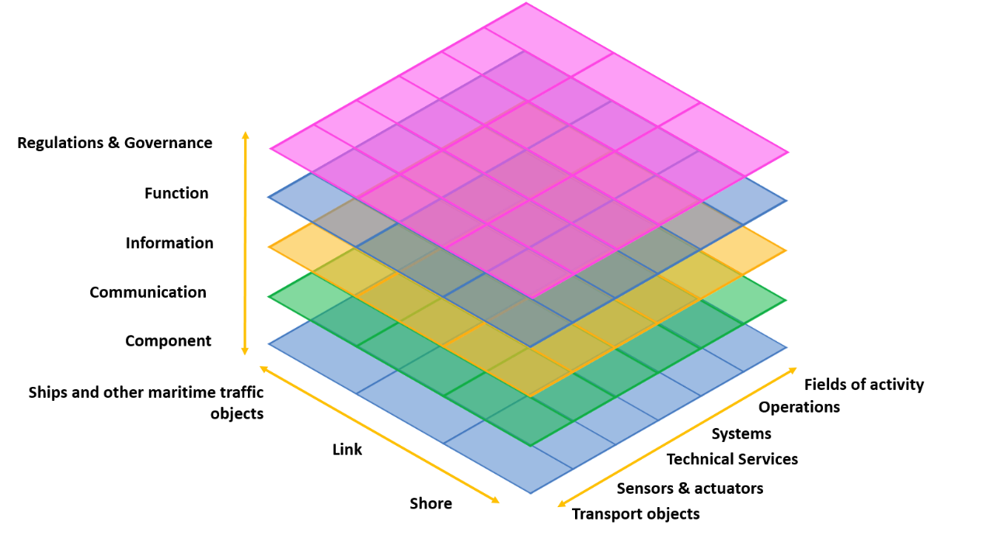
- Maritime Architecture Framework
The different dimensions of the cube are further described below.
- Hierarchical axis:
- Transport objects: Entities of maritime transport processes such as vessels, floating objects and aircrafts operating in the maritime domain.
- Sensors and actuators: Local infrastructure for detecting objects with physical means, and receiving and processing the results with physical systems and hardware.
- Technical services: Single technical and logical services.
- Systems: Technical systems which integrate or use technical services for gaining a virtual representation and control of the transport processes.
- Operations: Global, regional, national and local operational perspectives used by companies or authorities (e.g. a traffic flow management).
- Fields of activity: Systems which support or manage different markets or eco systems along the maritime domain.
- Topological axis (This axis differs from the original RAMI cube by replacing life-cycle view by the datalink communications entities):
- Ships and other maritime traffic objects: Representing entities in the maritime domain (e.g., vessels). It covers the ship-side entities of the e-navigation architecture.
- Link: Representing entities dedicated to physically interact between maritime traffic objects and shore, such as telecommunication methods and protocols. Represents the three levels of Operational links, Functional links and Physical Links between ship-side and shore-side.
- Shore: Representing entities of the shore side infrastructure, activities and systems on shore including interfaces to logistical movements in/out of the maritime domain.
- Interoperability layers:
- Component: Required components in engineering terms. This includes, amongst others: systems, actors, applications, services and network infrastructure.
- Communication: Protocols and mechanisms for the interoperable exchange of data between components.
- Information: Data and information that is being used and exchanged between functions, services and components. It describes data and information objects including its semantic and data models.
- Function: Functions and (elemental) services including their relationships.
- Regulations and governance: Role and legal basis of international, regional or national (shipping) authorities.

Putting existing generic AtoN and VTS applications into the picture

This section shows how existing and well-understood AtoN applications fit into the larger picture of digitalisation of waterways and how they can be progressed by applying the concepts described in previous sections.

Overview

AtoN authorities have launched [Smart |Digital] AtoN projects with the purpose of marine environmental data collection and broadcast as well as for supporting regional navigation systems. It was recognised that in particular the [Smart |Digital] AtoN has potential to support the digitalisation of waterways as follows:
- The digitalisation of traditional AtoNs can provide digital information of the characteristics and status on the AtoN as such. That can be achieved through implementing of, for example, AIS AtoN devices in conjunction with remote monitoring and control systems. It is also necessary to evaluate the current degree of such monitored AtoNs and develop future development goals. This kind of application would render digital shadow to the monitored AtoN.
- Certain data can be collected and transmitted by [Smart |Digital] AtoNs which thus acts as an outpost of the waterway authority towards shipping. For example, collection and dissemination of environmental information such as channel water depth, hydrology and meteorology, identification and monitoring of above water objects information, and marking and early warning of construction, operations and buildings around waterways. The [Smart |Digital] AtoNs may also carry related sensors, developing service and data system, and updating structure, power system and communications links, as needed. Such [Smart|Digital] AtoN can contribute to electronic fence application in port areas.
- Electronic fence: The application system of electronic fence is a new model of AtoN services. It can provide intelligent navigation assistance, warnings or alerts to ships by setting up perception methods such as AIS, radar and CCTV, thereby increasing the content of AtoN services, diversifying maritime supervision and management methods, and further ensuring the safety of ship navigation in water areas.
Consequentially, the development of such digitalised AtoNs, especially the construction of multi-functional [Smart | Digital] AtoNs, have to meet new requirements in terms of availability and reliability, which needs to be given special attention during implementation and planning their maintenance schemes. These topics will be addressed in some more detail below.

Digital shadows of remotely monitored floating visual Aids

Systems for remotely monitoring the status of floating AtoNs and their equipment has been widely used over a decade now (Figure 16). These systems provide data flow from physical object (floating AtoN) to a digital monitoring system and may also prove means to remotely control (manually) the status and configuration of the physical object, thus creating a digital shadow (Figure 5). The digital shadow in this case is limited to the status of AtoN and its equipment, excluding for example the physical condition of the AtoN structures. This type of digital shadow of an AtoN is updated frequently but usually not continuously due to the energy and data link limitations. The IALA G1008, on Remote Control and Monitoring of Marine Aids to Navigation, gives extensive introduction on remote control and monitoring of marine AtoNs
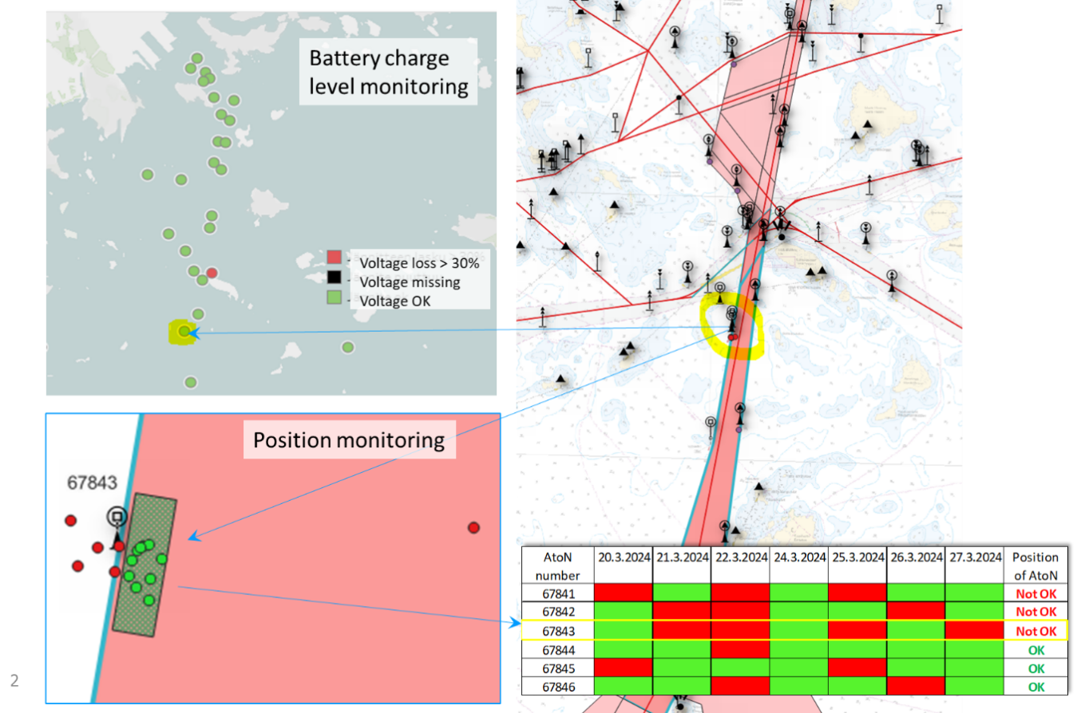
- Example of AtoN monitoring information.
The AtoN on-demand concept opens possibilities for upgrading the type of AtoN digital shadow described in the previous paragraph further to a digital twin. The AtoN on-demand concept has been introduced related to the use of occasional lights in low traffic areas and the possible need to increase intensity of AtoN lights in poor visibility conditions. This technology is described in more detail in IALA G1038, on Methods and Ambient Light Levels for the Activation of AtoN Lights. Activation method for an on-demand AtoN can be automated based on for example AIS information and/or information from visibility sensors (Figure 17) [26]. The automated on-demand AtoN will have automatic bi-directional data flow between physical objects in the waterway (i.e. AtoN, AIS, visibility sensors) and the digital model (Figure 5) thus it can be seen to form a limited scale digital twin.
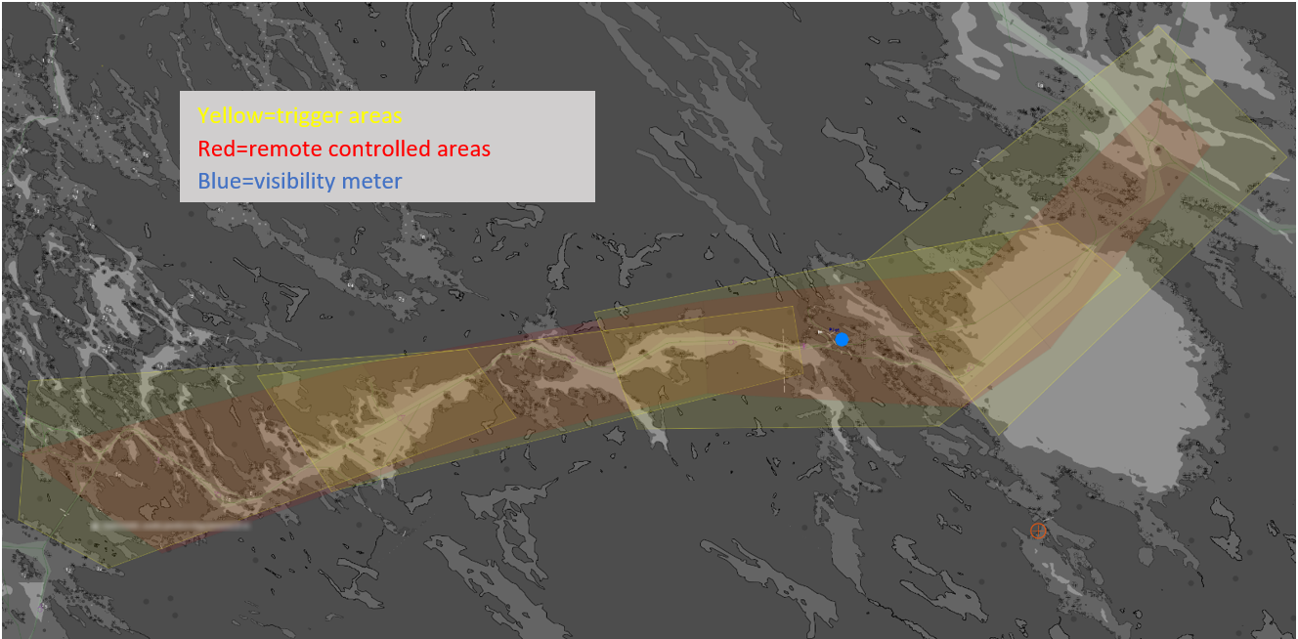
- Example of an on-demand AtoN used for increasing the intensity of AtoN lights based on traffic information from AIS (yellow trigger areas) and prevailing visibility (blue visibility meter).

Digital AtoN as outposts of the waterway authority towards shipping

There are few fixed objects in the sea, especially in coastal waterways, and floating AtoNs are generally set within the waterways. Digital/intelligent AtoNs utilize the existing point resources of navigation aids and possess inherent resource advantage. Digital/intelligent AtoNs are generally set in important water areas such as entrances, turning points, and warning zones. Compared with remote sensing and modelling, digital/intelligent AtoNs can more directly and accurately collect real-time data on water depth, water quality, hydrology, meteorology, visibility, and related information of ships by installing sensor facilities on traditional AtoNs.

Application Scenarios
There are at least the following application scenarios for digital/intelligent AtoNs:
- Assisted navigation function: By installing hydrological and meteorological sensors on AtoNs, the navigation assistance function of AtoNs can be extended to collect relevant information and provide hydrological and meteorological navigation assistance services such as wind speed, wind direction, current speed, and current direction for surrounding ships.
- Monitoring function: According to the requirements, CCTV, small radars, sonars, and other sensor facilities can be installed on AtoNs to utilize them as important monitoring points on the water to identify ships, offshore facilities, and marine organisms to provide monitoring information services to relevant users.
- Assisted decision-making function: Installing small AIS base stations on AtoNs in the edge waters of AIS base station coverage or in waters with weak AIS signals can expand the coverage of AIS, avoid time slot conflicts in waters with high ship density, prevent the occurrence of "invisibility" situations, and achieve traffic flow observation, which can provide decision-making references for maritime VTS. In addition, hydrological, meteorological, visibility, wave height, and other navigation assistance service information can provide decision-making support for ship management, dispatching, emergency search and rescue, etc. It can also provide important decision-making information for pilotage and maritime management departments to determine whether to enter or leave the port, berth or unberth, and whether pilots should board or disembark. Decision support also includes dredging decision support, seabed evolution analysis and dredging area positioning.
Maritime communication mainly utilizes satellite communication, combined with the application of VHF to achieve the communication between ships and shore. Due to the high cost of satellite communication and the limitation of VHF in data transmission, communication between shore and ships has always been the main bottleneck of maritime communication systems. Based on the demand for maritime communication, coastal AtoNs have the characteristics of wide distribution within the waterway range, proximity to the waterway, and existing energy supply, they have natural advantages as a platform for carrying maritime communication sub-base stations, and can serve as a platform for maritime communication base stations to establish a high-speed data transmission network covering the entire maritime waterway.

Service provision considerations
The following should be considered related to the management of data collected or transmitted via digital/intelligent AtoNs:
- Data flow: Information collection terminals collect information around the AtoNs and transmit the information to the information integration terminal in a centralized manner. The information integration terminal decodes and preprocesses the data information generated by each information collection terminal on the AtoN. According to the needs, the required data can be re-encoded and forwarded to specific local information communication terminals, and all data can be encrypted and transmitted to the information service system through 4G/5G mobile communication terminals. Navigation function-related information can be broadcast or addressed to surrounding ships through the AIS terminal. The energy system is connected to the information integration terminal, which supplies power to the information collection terminal and the information communication terminal, and the information integration terminal can manage each power-consuming device. The shore-based data center receives and stores the complete data flow and can provide it to third parties for retrieval through the API data service interface of the data center as needed.
- Regional information services: According to the recommendations of the International Navigation Association e-Navigation Construction Guide (G1139) and the IALA MARCOM Manual, the service to users should be broadcast directly by the beacon sub-station.
- Service mode: Based on the standardization and universality of AIS, the AIS short message service mode should be adopted to offer extended navigation assistance services to regional ships.
- Information category: The navigation-related information of digital/intelligent AtoNs can be mainly broadcasted through physical AIS AtoNs by the following messages to provide extended navigation services for nearby vessels:
- AIS Message type 21 - Identification of AtoNs and current geographical position status ;
- AIS Message type 8 - Meteorological and hydrological data or other IMO information;
- AIS Message types 12 and 14 - Navigation hazard information;
- AIS Message type 6 - Binary custom message information.
- Frequency of information sending: According to the AIS message transmission rules that vessels must receive a message at least once during their passage through an AtoN, the following transmission frequencies in Table 9 are recommended.
- AIS message transmission frequency
Message type | Recommended sending interval [min] | Optional recommended interval [min]
21 | 3 | 3，5，6，10
8 | 10 | 3，6，10，15，30
12 | 10 | 3，6，10，15，30
14 | 10 | 3，6，10，15，30
6 | 10 | 3，6，10，15，30

- Data service interface: After receiving the sensor data collected by one or more digital/intelligent AtoNs, the shore-based data center should store the data according to their positions and the information content collected by the sensors. Meanwhile, API interfaces should be developed to the background system to provide location-based multi-information services to other relevant users on the shore.
- Information Security: It is recommended to refer to the ISO27001 document Information Security Management System.

Design requirements
The following design principles should be taken into account:
- Principle of adaptability: Digital/intelligent AtoN should adapt to the current situation, development needs and planning of the waterway. They should conform to the characteristics of the waterway area, be planned in a coordinated manner, be adapted to local conditions, focus on practical results, and be moderately advanced.
- Principle of functionality: The design of digital/intelligent AtoNs should fully consider the direction and depth of the waterway, while also taking into account the correlation and support of port conditions, meteorological environment, hydrological characteristics, and vessel types. The functions of the waterway, vessels, and shore-based facilities should be linked and coordinated.
- Principle of economy: Under the premise of ensuring the basic functions and performance of digital/intelligent AtoNs, cost-effectiveness should be fully considered. New technologies, materials, and processes should be utilized to optimize the design plan and select cost-effective facilities and equipment, ensuring the rationality of investment and the sustainability of returns, and meeting the sustainable development needs of digital waterway management and vessel operations.
- Principle of expandability: Digital/intelligent AtoNs should not only have the current required functions but also have expandability and extensibility. They should have the ability to upgrade technology and expand functions to meet the possible new application needs in the future and adapt to the changes in future technological development and waterway management requirements.
- Principle of standardization: Uniform design specifications, management and maintenance, and technical standards should be followed, as well as the involved status information, communication protocols, data formats, and equipment interfaces, to ensure seamless connection and data exchange between different manufacturers and types of digital/intelligent AtoNs. The data and transmitted information of digital/intelligent AtoNs should be uniformly encoded and standardized to facilitate information identification, processing, and analysis.

Location selection
The location of the [Smart | Digital] AtoN to be deployed as an outpost of the waterway authority needs to be carefully selected. According to the actual application requirements, the following locations should be preferred:
- Important ports, waterways and navigation routes: Important ports and waterways have high vessel traffic volume and navigation density. The installation of digital/intelligent AtoNs helps optimize vessel passage routes, reduce waiting time, improve waterway navigation efficiency, enhance the navigation capacity and service level of important ports to promote the prosperity and development of port economies.
- Narrow waterways: Narrow waterways have limited space, and vessel navigation often requires waiting, coordination, or may lead to accidents such as collisions and grounding. Digital/intelligent AtoNs can monitor the waterway boundaries and vessel traffic in real time, promptly detect and handle potential problems, and ensure the smooth and safe passage of the waterway.
- Waterway entrances and turning points: Waterway entrances are critical areas for vessels to enter or exit the waterway, often with complex currents and heavy traffic. Digital/intelligent AtoNs can provide real-time information on the position, width, and depth of waterway entrances, helping vessel operators accurately identify the entrance location and guide vessels to enter or exit the waterway smoothly, reducing the time spent waiting and wandering in the entrance area and avoiding entering dangerous areas or collisions. At waterway turning points, vessels need to adjust their course to adapt to the new waterway direction. Digital/intelligent AtoNs can provide accurate information on the position, turning angle, and conditions of the waterway ahead, helping vessel operators prepare in advance and adjust their course to ensure a smooth and safe passage through turning points.
- Reef shoals and other water flow variations in large areas: The water flow in reef and shoal areas is complex and varied, and there may be obstacles such as hidden reefs and shallow areas, posing a threat to vessel navigation. Digital/intelligent AtoNs can provide real-time key navigation information such as water depth, current, location of obstacles, and flow velocity and direction in these areas, helping ship operators identify dangerous waters, determine current changes, accurately assess the waterway and its surrounding conditions, plan and formulate safe and efficient navigation routes, and effectively avoid incidents such as collisions and grounding.
- Areas requiring environmental monitoring: Some areas of the waterway have complex natural conditions and sensitive ecological environments. Digital/intelligent AtoNs integrate multiple sensors and can monitor environmental factors such as water quality in real time, providing accurate environmental data support for management departments. This helps prevent pollution spread, strengthen the protection of the ecological environment around the waterway, and is of great significance for assessing the environmental conditions of the waterway, predicting environmental changes in the waterway, and formulating environmental protection measures.
- Accident-prone areas: Digital/intelligent AtoNs can monitor navigation information such as water flow, wind direction, visibility, and the navigation trajectories of ships in real time. In accident-prone areas, obtaining navigation information will help ships identify risk factors, issue warning signals to ships, and conduct targeted ship maneuvering, effectively avoiding or reducing the occurrence of accidents. The use of digital/intelligent AtoN sensors and data analysis technology can also provide an important basis for management departments to discover accident patterns, judge accident trends, quickly dispatch rescue forces, shorten rescue time, improve rescue efficiency, provide accident analysis data, and determine maritime liability for accidents.
- Dense traffic areas: In dense traffic areas, the volume of ships is large, and the navigation risk increases accordingly. Digital/intelligent AtoNs, based on real-time monitoring of traffic volume and ship dynamics, can also integrate traffic management systems to monitor the volume and navigation status of ships in the waterway in real time, guiding ships to pass through traffic-intensive areas more efficiently and orderly, reducing navigation delays and traffic congestion, which can help improve the passage capacity and utilization of the channel.
- Waterway warning areas: Setting digital/intelligent AtoNs in warning zones can clearly mark dangerous areas or elements that require special attention, guiding ships to travel along the designated route and speed, reducing the crossing and mutual interference between ships, which can remind ship operators to operate carefully to avoid collisions, grounding and other accidents.

Engineering considerations for Digital AtoNs
Consists of six parts: information collection terminal, information integration terminal, information communication terminal, information service system and energy support system.
- Information collection terminal
- Information integration terminal
- Information communication terminal
- Information service system
- Energy support system
- Operation and maintenance system
Technical requirement
- Installation requirements
- Standardization requirements
- Fast and simple requirements
- Environmental suitability
- Communication requirements
Choose one or more of the following modes of communication:
- 4G / 5G communication capability
- AIS communication
- Beidou communication
- Satellite communication
- Energy requirements
- Power supply adaptability
- Energy support system]

Vessel Traffic management by using digital twins

Creating a digital twin of a waterway can significantly enhance vessel traffic management, as it allows the simulation of various scenarios involving different types of vessels safely navigating the waterway. This can include the selection of hydrological or weather conditions and traffic scenarios, including both routine and emergency situations. A digital twin is especially valuable during the construction or renovation of a waterway, as it enables the simulation and analysis of vessel traffic management in the early design stages.
For existing waterways, the digital twin also serves as a valuable training tool. It allows port personnel, such as pilots or VTS operators, to simulate and practice managing vessel traffic in a safe environment.

OUTLOOK ON FUTURE, BUT IMMINENT PARADIGMATIC DEVELOPMENTS

Overview
This chapter introduces some further steps in the digitalisation of waterways that may or will be taken in the future. While the maturing of the development and/or implementation of these paradigmatic concepts is still future as seen from the date of the publication of this edition of this guideline, international standardisation work on them has already started or has gained already a certain degree of maturity. Hence, these paradigmatic concepts are to be considered imminent. Therefore, the following developments are introduced here as an outlook together with references to the international standardisation domains dealing with them presently. These paradigmatic concepts will be further elaborated in future editions of this guideline as they gain higher degrees of maturity.

Concept of the Metaverse and its derivatives

So far, this guideline has introduced the generic paradigmatic concepts of a data model, a data shadow, and a digital twin. These concepts have in common, that they create a digital data representation about physical or virtual entities of whatever kind which may be used for certain improvements regarding the functioning of those physical or virtual entities. The concept of the metaverse uses this digital data representation together with further amendments to allow humans (and potentially their avatars) to enter the virtual representation of the real physical environment, the metaverse.
It is assumed, that by entering the metaverse interactions of humans (and potentially their avatars) with functions of the physical entities represented there can be even more efficient.
To cater with the complexities of this concept when applied to the whole of reality, certain subset derivatives of the metaverse have already been defined, such as the citiverse. Some point in the future, there may be established a derivative of the metaverse for waterways, maybe called waterverse.
Technologies needed to enter the metaverse range from augmented reality displays via virtual reality headsets to cyber-human implants, all of which are already under standardisation in international organisations.

Concept of the Physical Internet

So far, this guideline has concerned itself with concepts of digitalisation of the waterways and of its individual infrastructure components. The paradigmatic concept of the Physical Internet (PI) builds on these but reverts back to the original purpose of waterways, that is the transport of cargo. In a nutshell, the idea of the PI is to enable an appropriate and standardised container (of cargo, to start with) to be routed or even route itself through the whole of the intermodal transport network from consigner to consignee using any available mode of transport. That resembles the idea of the Internet with the routing of data containers applied to physical containers. Because any mode of transport can be employed to that end, the different modes of transport are transparent to the decision making of the cargo containers routeing themselves through the transport network at a certain point in time, this concept is sometimes also called synchromodality.
It should be noted that the containers as mentioned above, should not be construed as TEU sea containers by default, but may be much smaller, and that the vessels in the case of the waterway transport part may be quite small while still having all features of vessels.
The PI requires a high degree of automation or even autonomous entities throughout, for example at points of change of mode of transport but also en-route within a specific mode of transport. Regarding the waterway this would mean specific support for approaching vessels to berths along the waterways and in ports.

DEFINITIONS

The definitions of terms used in this Guideline can be found in the International Dictionary of Marine Aids to Navigation (IALA dictionary) at http://www.iala-aism.org/wiki/dictionary and were checked as correct at the time of going to print. Where conflict arises, the IALA Dictionary should be considered as the authoritative source of definitions used in IALA documents.
Preliminary tentative list of terms used in the guideline:
- Autonomous vessel/vehicle
A vessel, which decision-making and execution of navigation (‘sailing’) are performed autonomously in the strict sense of the word and as the regular case by an appropriate machinery of the vessel itself without on-board or remote human interaction. Whether the AV actually is crewed or uncrewed is irrelevant in regards to its navigating functions as long as the shipboard machinery performs them as the intended regular case.
- Autonomous Vessel Control Centre (AVCC)
A shore-based centre that monitors and controls an AV and is operated by or on behalf of the shipping company that also operates the AV. Since an AV, by its very definition, does not need a operation by crew or human remote control in regular cases, there will likely be a requirement that the AV is constantly monitored and contingency response is active in non-regular modes of operation or even malfunction of the AV. Hence, Autonomous Vessel Monitoring & Contingency Response is the main functionality to be performed by the AVCC. Since an AV may fall back to an ROV as part of the contingency response, the AVCC may also fall back to an RCC. AV adapted AtoN
- Citiverse
The Citiverse is a concept or term that generally refers to a digital, virtual, or conceptual universe centered around cities or urban environments. In urban planning and smart cities the he Citiverse can be envisioned as a digital twin or virtual replica of a city - an interconnected, immersive digital environment that models urban infrastructure, social dynamics, transportation, and more. This helps city planners, governments, and citizens visualize and manage city operations efficiently. It can also be used as a brand or project name for platforms or ecosystems that integrate urban data, IoT, AI, and social tools to create a "universe" of city-related digital services.
- Common Shore-based System Architecture
The CSSA is defined as a standardized framework to harmonize shore-based marine aids to navigation (AtoN) systems. The CSSA provides a modular, interoperable, and flexible architecture for managing and controlling marine AtoNs such as lighthouses, buoys, beacons, and other navigation aids, especially when these devices are remotely monitored or controlled.
- Connected vessel
A Connected Vessel refers to a ship that is equipped with digital communication technologies enabling it to exchange data and information with shore-based systems, other vessels, and maritime infrastructure in real time or near-real time.
- Digitalized waterway
Comprehensively utilizing surveying and mapping remote sensing, geographic information system, computer, Internet of Things, cloud computing and other technologies to digitalize and network waterway jurisdiction areas, service objects and management activities, and establish waterway information infrastructure and platform systems with network-oriented data as the core. It has the functions of dynamic monitoring of waterway changes, waterway maintenance, network management, waterway data
- Match principle
In digitalization, the match principle generally refers to aligning digital solutions or technologies closely with the specific needs, processes, and goals of a business or system. It means ensuring that the digital tools “match” the actual requirements rather than just adopting technology for technology’s sake.
- Metaverse
The metaverse is a collective virtual shared space created by the convergence of virtually enhanced physical reality and persistent virtual worlds. It is like the internet in 3D, a fully immersive digital universe where people can interact with each other, digital objects, and environments in real-time.
- Remote Control Centre (RCC)
A shore-based centre that performs the remote operation of an ROV and is operated by or on behalf of the shipping company that also operates the ROV.
- Remotely operated vessel/vehicle (ROV)
A vessel, which navigating functions are performed remotely as the regular case from a Remote Control Centre (RCC) by a human at that centre. Whether a ROV is actually crewed or uncrewed is irrelevant in regards to its navigating functions as long as they are performed remotely as the intended regular case.
- Smart/digital AtoN
A smart AtoN is an advanced navigational aid equipped with sensors and communication technology that enables it to monitor, collect, and transmit real-time data about its status and the surrounding marine environment. Unlike traditional AtoNs, which rely solely on fixed signals (lights, shapes, sounds), smart AtoNs provide dynamic information that can be accessed remotely by Vessel Traffic Services (VTS) and mariners to enhance situational awareness, safety, and efficiency of navigation.
- Synchromodality
Flexible and dynamic transport of goods from A to B using multiple transport modes. Allows real-time selection of the transport mode during the voyage based on for example the cost, speed and availability of different transport options responding to changing conditions like disruptions in the transport chain.
- Traditionally operated vessel
A vessel, which navigating functions are performed by a crewmember on-board by using appropriate Human-Machine-Interfaces (HMI) designed for that task. The degree of automation supportive of that task is encapsulated within the traditional operation and is therefore irrelevant here as long as the on-board human master is in charge of the vessel’s navigation.
- Vessel
Ship or large boat (Cambridge dictionary) with purpose of carrying cargo and/or persons.
- Waterborne Vehicle
Any vehicle designed for travel across or through water bodies, such as a boat, ship, hovercraft, submersible or submarine (Wikipedia)
- Waterverse
A concept similar to the Citiverse, but for waterways. A comprehensive digital twin platform designed to simulate, visualize, and optimize waterways and fairways — including rivers, canals, coastal shipping lanes, and recreational boating areas. It integrates real-time data, historical records, environmental models, and stakeholder inputs into a single immersive virtual environment.
- Waterway
A waterway is a navigable route through a body of water marked and maintained with marine AtoNs to ensure safe passage for vessels.

abbreviations

2D Two Dimensional
3D Three Dimensional
AIS Automatic Identification System
AML Additional Military Layers
API Application Programming Interface
ASF Additional Secondary Factors
ASM AIS Application Specific Messages
ATON Aids to Navigation
BAM Bridge Alert Management
CAS Information to support Calamity Abatement (CAS)
CAT Category of ILS Approach
CCTV Closed-Circuit Television
CHD Information for Waterway Charges and Harbour Dues
C-ITS Cooperative Intelligent Transport Systems
CMM Capability Maturity Model
CSSA Common Shore-based System Architecture
DGNSS Differential GNSS
DIWA Masterplan Digitalisation of Inland Waterways
DSC Digital Selective Calling
ECDIS Electronic Chart Display and Information System
ENC Electronic Navigational Chart
EU European Union
FIS Fairway information Services
GIS Geographic Information System
GMDSS Global Maritime Distress and Safety System
GMWG Geospatial Maritime Working Group
GNSS Global Navigation Satellite System
HMI Human-Machine Interface
IEC International Electrotechnical Commission
IEHG Inland ENC Harmonization Group
IHO International Hydrographical Organization
ILC Information to support Law Compliance
ILS Instrument Landing Systems
IMO International Maritime Organization
INS Integrated Navigation System
IOC Intergovernmental Oceanographic Commission
IoT Internet of Things
ISO International Organization for Standardization
IT Information Technology
ITL Information to support Transport Logistics
MAF Maritime Architecture Framework
MASS Maritime Autonomous Surface Ship
MKD Minimum Keyboard and Display
MS Maritime Service
MSC Maritime Safety Committee
MSI Maritime Safety Information
NATO North Atlantic Treaty Organization
PI Physical Internet
PIANC World Association of Waterborne Transport Infrastructure
RAMI Reference Architecture Model for Industry
RENC Regional ENC Coordinating Centres
RIS River Information Service
PNT Position, Navigation and Timing
SERCOM WMO Service Commission
ST Information to support Statistics
TEU Twenty-foot Equivalent Unit
TIS Traffic information Services
TM Information to support Traffic Management
TRL Technology Readiness Level
UKCM Under Keel Clearance Management
V2V Vessel-to-Vessel
VTS Vessel Traffic Service
WMO World Meteorological Organization

[placeholders]

references

Consolidate the numbering in due course
- TM Forum White Paper. Digital Maturity Model (DMM): A blueprint for digital transformation. 2017.
- Lind, Mikael & Haraldson, Sandra & Lind, Kenneth & Lehmacher, Wolfgang & Svan, M & Renz, Mikael & Gardeitchik, J & Singh, Sukhjit & Zuesongdham, Phanthian. (2021). Ports of tomorrow: measuring digital maturity to empower sustainable port operations and business ecosystems. 82.
- Wouter Buck (Product Lead, Digital Business Solutions), Jan Gardeitchik (Senior Lead Digitisation, Digital Business Solutions), Arny van der Deijl (Tech Lead, Digital Business Solutions). Port of Rotterdam: Move Forward: Step by Step towards a Digital Port.
- ISO/IEC 30186 ED1 Digital twin – Maturity model and guidance for a maturity assessment (under development)
- Oltmann, J.-H. (2023) Technology in other modes of transport. DIWA Sub-Activity 3.5 Report. www.masterplandiwa.eu/documents.
- [Wikipedia-EN 2022c] English Wikipedia. 2022. Capability Maturity Model. 22 Jul 2022. Accessed 13 September 2022.
- JHO IALA Conf 2023 paper on AtoN for MASS
- IALA. IALA Workshop on Marine AtoN in the Autonomous World. Workshop Report.
- International Organization for Standardization. (2022) ISO/TS 23860:2022. Ships and marine technology – Vocabulary related to autonomous ship.
- Central Commission for the Navigation of the Rhine. (2018) ‘First international definition of levels of automation in inland navigation’ CC/CP(281)20.
- International Maritime Organization. (2021) MSC.1-Circ.1638. Outcome of the Regulatory Scoping Exercise for the Use of Maritime Autonomous Surface Ships (MASS). (3 June 2021).
- Lloyd’s Register. (2016) Cyber-enabled ships. ShipRight procedure – autonomous ships. Version 1.0.
- Carson-Jackson, Jillian. (2022). Terminologies in MASS. Presentation at [1]. NB: ‘Sheridan Levels of Autonomy’ are introduced there (slide 11) and mapped to IMO MASS levels of [4] (slide 12).
- Tchana de Tchana, Yvan & Ducellier, Guillaume & Sébastien, Remy. (2019). “Designing a unique Digital Twin for linear infrastructures lifecycle management.” Procedia CIRP. 84. 545-549. 10.1016/j.procir.2019.04.176.
- IMO. Strategy for the development and implementation of e-navigation (MSC 85/26/Add.1, annex 20)
- IMO. Descriptions of Maritime Services in the Context of e-Navigation (MSC.1/Circ.1610/Rev.1).
- PIANC. Inland Navigation Commission Report No 125/I Guidelines and Recommendations for River Information Services. 2019. ISBN 978-2-87223-265-9.
- COMMISSION REGULATION (EU) No 139/2014 of 12 February 2014 laying down requirements and administrative procedures related to aerodromes pursuant to Regulation (EC) No 216/2008 of the European Parliament and of the Council.
- ITU. 2021. Intelligent transport systems. Handbook on Land Mobile (including Wireless Access). Volume 4. 2021 edition. Geneva: ITU. 2021.
- IALA. Guideline G1113 Design and Implementation Principles for Harmonised System Architectures of Shore-Based Infrastructure.
- IALA. Guideline G1114 A Technical Specification for the Common Shore-based System Architecture.
- IEC 62890 Industrial-process measurement, control and automation - Life-cycle-management for systems and components
- IEC 62264 Enterprise-control system integration
- IEC 61512 Batch control
- NAVGUIDE 2018.
- IALA e-Bulletin, March 29, 2023. Finland – remote controlling AtoN lights. Available online: https://www.iala-aism.org/e-bulletin/e-bulletin-march-2022/finish-transport-infrastructure-agency/

Further reading

- [Reference on Physical Internet introduction]

Index
No index entries found.

- Explanations and examples of digitalisation levels derived from Capability Maturity Model (CMM)
The following text will give explanation and supporting examples of the terminology that is used for digitalisation levels in Section 2.3, Figure 1.
- Reactive
A waterway administration that has a website but only with static reference information, no interaction possibilities. Customer contact is primarily conducted via phone (voice) and traditional (paper) mail. Every waterway service offering has its own (customer) database. Management considers IT/digitalisation a purely supportive tool instead of a business enabler. Generally speaking, it is strongly advised to leave this DL and progress to higher DLs.
- Organised
‘Traditional digital features’ are interpreted here as those exhibited by well-established digital systems in the waterway domain such as AIS and S-57 based ECDIS.
‘Building digital capabilities’ is construed as the (systematic) building of digital capabilities is introduced to/by stakeholders in/of the waterway domain starting with this level.
- Digitised
‘Digital information exchange’ means, that data and/or information exchange is using pre-defined structures, such as machine-readable templates, as a pre-requisite and as opposed to e.g. bitmap-based documents. This in turn results in exchange of structured data/information as a rule, thus again prompting appropriate encoding, protocols, and interfaces supporting this exchange.
Examples: S-57-format of ECDIS (at present) and S-100-format (in the future); Notices to Mariners.
‘Limited real-time situational picture’ means that the positions and intents of all vessels in a given area are available but limited in terms of geography and/or technology.
Example: Radar coverage only on certain parts of the waterway, AIS coverage only on certain parts of the waterway, Radar-AIS-fusion only available for some areas covered by both radar and AIS simultaneously.
‘Advanced digital features in silos’ means that digital data/information is available and combined in an automated fashion to provide new services.
Example: berth occupation calculation based on AIS and berth polygon data.
- Connected
‘Advanced digital features aligned with partners’ means, that available digital data/information is combined automatically to provide new services across organisational boundaries.
Example: Waterway route calculation taking en-route limitations (as contained in Notices to Mariners) into account across areas of multiple organisations.
‘By default’ means that all communication data exchange (ship-ship, ship-shore) is done digitally machine to machine in a (semi) structured format. Spoken word via VHF or other means and/or unstructured data exchange (email, texting) are considered exceptional.
‘Full real-time situational picture’ means that positions and intents of all vessels in the entire area of competency of multiple organisations are available.
Example: Full AIS coverage, full Radar-AIS-fusion available in radar covered areas, every vessel intent is known or predicted.
- Intelligent
‘Digital transformation’ means that an entity has adopted digital technology throughout all its parts relevant for the IDL assessment. ‘Common goals for its implementation are to improve efficiency, value or innovation’.
‘Artificial Intelligence (AI) assisted process optimisation’ means…
Example: Authority patrol vessels are positioned at locations where the likelihood of their required use is the greatest (following from risk level prediction based on statistical and real-time data). Bridge operators are assisted by image recognition algorithms to detect potentially dangerous situations.
‘Predictive digital capabilities’ means…
Example: Future traffic situation, berth occupation, lock cycle and bridge openings are automatically predicted within a small probability bandwidth on a large scale.
‘Automated response to standard situations’ means…
Example: Vessels entering designated (even temporary) danger or no-go zones are automatically detected and contacted with increasing forcefulness to contain and mitigate potential unwanted events.

